Bilkent University

# Erasmus Registration Management System

*Project short-name: ERSMS*

Analysis Report

Kutay Tire - 22001787

Atak Talay Yücel - 21901636

Yiğit Yalın - 22002178

Borga Haktan Bilen - 22002733

Berk Çakar - 22003021

Instructor: Eray Tüzün

Teaching Assistant(s): Muhammad Umair Ahmed

Iteration 1

November 5, 2022

This report is submitted to the Department of Computer Engineering of Bilkent University in partial fulfillment of the requirements of the Object-Oriented Software Engineering course CS319

**Contents**

**Erasmus Registration Management System** **1**

**1 Introduction** **4**

**2 Current System** **4**

**3 Proposed System** **5**

3.1 Overview 5

3.2 Functional Requirements 6

3.2.1 Signup 6

3.2.2 Login 7

3.2.3 Views 7

3.2.3.1 Administrator View 7

3.2.3.2 Exchange Coordinator View 7

3.2.3.3 Instructor/Course Coordinator View 7

3.2.3.4 Department Chair/Dean View 8

3.2.3.5 Student View 8

3.2.3.6 OISEP View 8

3.2.4 Auto-Placement of Students 8

3.2.5 To-Do Lists 9

3.2.6 Auto-Assessment of Workload 9

3.2.7 Process Monitoring 9

3.2.8 Messaging 9

3.2.9 General Form, Request and Decision Logging 9

3.2.10 Previously Accepted and Transferred Course Database 10

3.2.11 Social Aspect 10

3.3 Non-functional Requirements 10

3.3.1 Usability 10

3.3.2 Reliability 10

3.3.3 Security/Safety 11

3.3.4 Performance 11

3.3.5 Maintainability 11

3.4 Pseudo Requirements 11

3.4.1 Implementation 11

3.4.2 Packaging Requirements 12

3.4.3 Operational Requirements 12

3.5 System Models 13

3.5.1 Use Case Model 13

3.5.2 Dynamic Models 32

3.5.2.1 Activity Diagrams 32

3.5.2.1.1 Activity Diagram for Pre-Approval Form 32

3.5.2.1.2 Activity Diagram for CTE Form 33

3.5.2.1.3 Activity Diagram for Placement 34

3.5.2.2 State Machine Diagrams 35

3.5.2.2.1 State Diagram for Roles of Users 35

3.5.2.2.2 State Diagram for Pre-approval Forms 35

3.5.2.2.3 State Diagram for Equivalence Requests 36

3.5.2.2.4 State Diagram for CTE Forms 36

3.5.2.3 Sequence Diagrams 37

3.5.2.3.1 Sequence Diagram for Pre-approval Forms 37

3.5.2.3.2 Sequence Diagram for CTE Forms 37

3.5.2.3.3 Sequence Diagram for Equivalence Requests 38

3.5.3 Object and Class Model 39

3.5.4 User Interface 40

3.5.4.1 Login and Sign Up Screens 40

3.5.4.2 Exchange Coordinator Dashboard Screen 41

3.5.4.3 Exchange Coordinator Forms Screen 42

3.5.4.4 Logging Screen 43

3.5.4.5 Placements Screen 43

3.5.4.6 Messages Screen 44

3.5.4.7 Instructor/Course Coordinator Course Equivalence Requests Screen 44

3.5.4.8 Profile Screen 45

3.5.4.9 Student Dashboard Screen 45

3.5.4.10 Student Form Submission Screen 45

3.5.4.11 OISEP Score Table Upload Screen 47

**4 References**48

**Analysis Report**

*Project short-name: ERSMS*

# 1 Introduction

Our project is an Erasmus application management software that mainly focuses on easing up the jobs of students, coordinators and other stakeholders. To this end, our team aims to remove the paperwork that is currently done and replace it by digitalized documents to speed up the process. Some of these documents are pre-approval forms, syllabuses of the courses given at the host institute for evaluating equivalence for the classes at home universities, and course transfer and exemption forms. Students will be able to send these forms through our app, leaving very little work to-do by hand for the Erasmus coordinators.

The application also contains additional features that will further facilitate the process. Placements of the students to their host universities will be conducted automatically by the system based on their choices. Moreover, the outgoing students will be able to monitor the previously accepted courses at each university, see the information of other students that share the same host university and check their language exam scores if the host university requires one. For the Erasmus coordinators, a to-do list will be created by the system so that they won’t miss out anything and can track the process in a more organized way.

From the above required updates, it can be deduced that the current Erasmus application management process is cumbersome and difficult to handle. Especially in the digital era, the use of paperwork is definitely outdated with no benefit to students or coordinators. Therefore, we intend to solve this issue and other problems in the current system by making the entire process online and adding additional features which will be convenient for both parties, coordinators and students.

# 2 Current System

Our team has attended the presentation given by the stakeholder of this project, Can Alkan. According to that presentation, a great number of tasks are done manually. For example, Erasmus coordinators place the applied students to exchange schools by hand based on a score table supplied by the administrative staff. Besides that, our observations on the basis of Can Alkan’s presentation and current exchange program management procedure are the following [1]:

* Selected students are placed manually by the department exchange coordinators (Can Alkan and Ayşegül Dündar) according to the score table prepared by the Bilkent University Office of International Students and Exchange Programs.
* Exchange coordinators cannot arrange appointments with outgoing students or directly message those students. Can Alkan mentioned that even a simple button that triggers the email application (i.e., Thunderbird) with the students email address would be beneficial.
* For approving elective courses, exchange coordinators receive the corresponding course’s (course that is given by the host institute) syllabus over the email from the outgoing student.
* For must courses, the syllabus of the course given at the host institute is inspected and approved by the corresponding course coordinator at the Bilkent University.
* Previously accepted and transferred courses (given at the host institutes) are held in a spreadsheet.
* In the current system, courses from the exchange schools that were previously evaluated as having an equivalent course in Bilkent University are not logged in a proper manner. Moreover, if the student wants to have the non-equivalent courses taken in the exchange school counted at Bilkent University, he/she needs to get an approval manually by following a particular procedure (as previously mentioned).
* Outgoing students propose the courses that they want to take at the host institute by preparing a pre-approval form by hand while also adding the equivalent courses at the Bilkent University. Students submit this form by hand or by e-mail to the exchange coordinator.
* Even though a pre-approval form is valid and approved by the exchange coordinator, after the exchange period ends and host institute sends the transcript of the students, exchange coordinators again prepare, with the guidance of pre-approval forms and previously accepted course list, and submit a form called “Course Transfer and Exemption Form” to the Faculty Administration Board. This form contains the same course information from the pre-approval form but this time students’ grades are included. Considering those grades and the overall sufficiency of the courses, in addition to exchange coordinator, department chair and the dean signs and approves the courses taken at the exchange school to be counted in Bilkent University.
* Since the current system is completely manual, Erasmus coordinators do not have an automatically generated task guidance mechanism (i.e., “Which job should I complete now?”), also known as “to-do lists”.
* Workload assessment between the exchange coordinators is done manually based on a mutual agreement. For example, Kingston University is assigned to Can Alkan whereas AGH is assigned to Ayşegül Dündar.
* Aforementioned forms are not stored in a database, therefore searching and querying the forms is difficult.
* Students are unaware of the status of their submitted forms and approvals unless the Erasmus coordinators notify them.

# 3 Proposed System

## 3.1 Overview

From our team’s perspective, using manual methods in exchange application management is not practical enough to operate such a critical and sensitive subject for students. Moreover, we think that academicians should not spend an excess amount of time and effort dealing with paperwork and errands. Therefore, we propose to create a web application for the benefit of all parties involved in the exchange application process.

Our system will cover the functionalities that are done by hand (mentioned in section 2) and digitalize these functionalities with little to none paperwork. First step of our application is the login and sign up screen. After the login screen, users will be provided with different aspects of the system depending on their roles. For instance, an exchange coordinator will be able to list, query, and approve the submitted forms. Also, they can reach the students’ details such as application information, application status (i.e., approved, canceled), and more. Then, if they desire, they can send messages (or emails) to students and arrange appointments with one click. And most importantly, ERSMS provides some features that will ease the exchange coordinators’ tasks significantly. To start with, ERSMS will allow exchange coordinators to perform automatic placements of the outgoing students, based on the score table prepared by the administrative staff. Furthermore, exchange coordinators will have a to-do or a task list which will help coordinators to organize and manage the waiting tasks. This to-do list will consist of notifications such as “Student A has uploaded a pre-approval form”, “Instructor B has approved the equivalency for the course X”, or “Student C has canceled their exchange application”. Last but not least, ERSMS will have a workload distribution mechanism to ensure that the work is equally divided between the exchange coordinators. To illustrate, the exchange coordinators will divide the schools among themselves, and to-do lists will be created based on the schools that exchange coordinators are individually responsible for.

On the other hand, if the logged in user is a student, then he/she will be able to use different functionalities. According to that, students will be able to submit all kinds of forms or documents (e.g., pre-approval form, syllabuses) completely digital. They will be able to list the previously accepted equivalent courses. If a course at the exchange school is not listed as equivalent at Bilkent University, students will be able to use ERSMS to fill out a form requesting for equivalence. Moreover, they will be able to keep track of their application and the submitted forms’ status (i.e., approved, pending), including the Faculty Administration Board’s decision. Students will be able to see the to-do list for the tasks that should be done before and after the mobility. Finally, students will be able to send messages to exchange coordinators and arrange appointments with them over this messaging feature.

In summary, ERSMS proposes a web application which offers automated solutions for both exchange coordinators and students during the exchange application process.

## 3.2 Functional Requirements

### **3.2.1 Sign Up**

For this kind of an application, it will be appropriate if the login credentials of users are synchronized with the STARS. However, at this point of the development, it is not possible for our team to assume such an integration with another platform. Therefore, ERSMS will have its separate sign up and login system. As it can be understood, the first part of this authentication system is a sign up page. However, for the non-privileged users such as students, this sign up page will only be active after the course coordinators complete the automatic placement procedure. This way, we ensure that irrelevant students will be kept out of the system. In this page, users will be asked to fill in the required information fields such as name, surname, Bilkent University ID Number, Bilkent University email, and password. Before proceeding, if the entered email address is not under Bilkent University domain (bilkent.edu.tr), sign up will be instantly failed. After checking that point, if the given Bilkent University ID Number has a match in our automatic placement logs, a confirmation email will be sent to the entered email address. Following the confirmation sign up process will be completed. On the other hand, privileged accounts such as course coordinator will be created from the administrator account’s panel. An initial administrator account is created upon the deployment of the ERSMS. Admin users will be able to register other users to the system.

### **3.2.2 Login**

Login process will begin when the user submits his/her email and password. If there is a valid account with the submitted email the password, technically, the hash of the password, will be checked. If the submitted password is also correct the user will be redirected to a specific view (or page). For instance, if the user has a student role system will redirect him/her to the student page. If a user enters the password or email incorrectly the access will be denied until all login credentials are correctly submitted.

### **3.2.3 Views**

According to the user’s role, the user will be authorized to use a specific view. These views will be described in detail (i.e., role specific functions) following this section. Other than that, all users will be able to reach their profiles which include relevant information regardless of their role. Similarly, each user will have a view for messaging with other users.

#### 3.2.3.1 Administrator View

Administrators are the most privileged users in ERSMS in terms of application-side configuration. Therefore, their view on the ERSMS application includes the components for adding, managing, and removing all kinds of users. For the user management, they will be able to edit user profiles, change user roles, they can set application settings such as language and time zone. They will be able to add new roles and edit roles’ permissions if necessary. Lastly, they will be able to access detailed information about the system where the ERSMS runs and application logs.

#### 3.2.3.2 Exchange Coordinator View

Exchange Coordinators are greeted with a to-do and notification dashboard which helps coordinators to do their tasks in an organized way. This dashboard is powered by our workload balancing mechanism between the coordinators. Moreover, exchange coordinators will be able to reach components for approving and signing the student submitted pre-approval forms digitally. Also, these forms will be logged to the ERSMS’ database and exchange coordinators will be able to search, filter, and list previous forms. Similarly, they will be able to access a panel to put “Course Transfer and Exemption” into action for returning students. Besides that, it has to be mentioned that exchange coordinators have a view for triggering the automatic placement process. On the other hand, exchange coordinators can register, other exchange coordinators, instructors/course coordinators, department chairs/deans, and students to the application. Additionally, exchange coordinators will be able to cancel the placement of the students depending on some conditions such as an unsatisfactory GPA at the Bilkent University school (which will remove the student from the exchange process completely). Lastly, exchange coordinators will be able to arrange appointments with students using the messaging view. This view will also include the previously accepted and transferred courses database and exchange coordinators will be able to manage this database.

#### 3.2.3.3 Instructor/Course Coordinator View

The instructor and course coordinators will be able to see the equivalence requests sent by the students for the courses given at the host institute. These requests will include the syllabus of the course given at the host institute and the course (code or name) given at Bilkent University that will be exempted. If the course coordinator or instructor finds the corresponding course satisfying for transferring the request will be approved, otherwise they will decline the request. This view will also include the previously accepted and transferred courses database and instructors/course coordinators will be able to manage this database.

#### 3.2.3.4 Department Chair/Dean View

Department Chair/Dean view will be limited to the approval of the “Course Transfer and Exemption” forms. Hence, they will have a panel to search, filter, and list previous CTE forms as well as with another view to approve or decline newly submitted CTE forms. This view will also include the previously accepted and transferred courses database and chairs and deans will be able to manage this database.

#### 3.2.3.5 Student View

Student view will start with a to-do list (based on the forms they need to submit or tasks they need to complete) and a notification dashboard. Students will be able to send equivalence requests for the courses that are not previously accepted or transferred by uploading the syllabus of the course given at the host institute (and the corresponding course code or name at Bilkent University) to the course coordinators and exchange coordinators. Students will also view and edit the details of their account and manage their exchange status (in essence, they will be able to cancel their exchange placements). Moreover, students will also be able to submit a pre-approval form for the courses they are going to take at the host institute. They may also be able to edit the pre-approval forms that are submitted but not yet confirmed by the coordinators. They may also send new pre-approval forms if the previously accepted form has been changed or the previously sent pre-approval form is denied. The status of the forms and requests, the forms that the student is involved in (pre-approval, course transfer form and equivalence request), will be visible by the student. Students will also be able to see the students who are also going to the same school (same host institute) as themselves or the students that previously went to the same school as themselves. Furthermore, students will be able to arrange appointments with the exchange coordinators via the messaging function. Lastly

#### 3.2.3.6 OISEP View

The officials of the OISEP (Office of International Students and Exchange Programs) will be able to upload or delete the score table spreadsheet using this view.

### **3.2.4 Auto-Placement of Students**

Based on the score table spreadsheet uploaded by the OISEP, student replacement will be done automatically by the system. However, only Erasmus coordinators can initiate this action by clicking the “Place Students'' button which is only visible to them. When the button is clicked, the placement process starts from the student with the highest score and ends when the bottom of the list is reached. The system will check the choices of the students, and place them if their chosen host school has an available quota. When the quota of the first chosen university is full, the system checks the second choice of the students. The algorithm continues in this fashion and if no university chosen by the student has an available quota, the student is not replaced and is in the waiting list. After the placement process, if a university still has an available quota, Erasmus coordinators can ask the students in the waiting list whether they want to go or not starting from the student with the highest score. Similarly, if another student cancels his/her application, Erasmus coordinators can ask the students if they want to reply to them via email.

### **3.2.5 To-Do Lists**

Both the Erasmus coordinators and the students will have a to-do list available on their pages.

For the coordinators to-do list includes:

* Approving a pre-approval form
* Approving an equivalent course given in the host school. (After the student sent the syllabus and got an affirmative answer from the instructor of that course.)
* Approving a course transfer form sent by the host university.
* Notification when a student canceled his/her application.

For the students:

* Send a pre-approval form for the courses that will be taken in the host university.
* Send the syllabus of the equivalent course in the host university (This is optional).

### 

### **3.2.6 Auto-Assessment of Workload**

The workload should be balanced between exchange coordinators if there exist more than one coordinator for the department. This is done by distributing universities among coordinators. Universities will be assigned to coordinators automatically. After that, Coordinators will be able to change the universities among themselves if they want.

### **3.2.7 Process Monitoring**

The students who applied to the exchange program will be able to track the status of their applications after the initial placements. They will be able to observe at which stage their exchange process is, whose approval they are waiting for, the problems encountered during the process and the required steps for them to do for their exchange process. Likewise, the authorities will be able to observe the decisions made by other authorities. The advantage of this process being on ERSMS is that the exchange related messages/mails/notifications will be gathered in a single platform. For example, the students may forget to send the carbon copies of the emails to all the related authorities. ERSMS will automate this process and will send the notifications to all the related authorities. Additionally, the application process can be canceled under student’s desire or exchange coordinator’s desire.

### **3.2.8 Messaging**

Users will be able to send messages to each other. This functionality will improve the connection between the stakeholders of the whole exchange process (department chair to student). This functionality will also make the arrangement of appointments between the exchange coordinators and students possible.

### **3.2.9 General Form, Request and Decision Logging**

The forms and requests that are sent by the users will be logged (stored) in the database. These forms and requests are, but not limited to, pre-approval forms, course transfer forms and course equivalence requests. Additionally, the decisions relevant to the requests and forms logged in the system will be also saved. For instance, the decisions made by the Faculty Administration Board (especially) regarding a student’s course transfer form will be logged in the system. The logs will also support query functionality for easier form and request management.

### **3.2.10 Previously Accepted and Transferred Course Database**

Previously accepted and transferred courses will be logged in a database which will be available to students, department chairs, course coordinators, instructors, exchange coordinators and deans. Additionally, the privileged users (in essence, course coordinators, instructors, exchange coordinators, deans and department chairs) will be able to manage previously accepted and transferred courses and add new accepted and transferred courses to the database.

### **3.2.11 Social Aspect**

Students will be able to view the information about the other students that are going or previously went to the same school as themselves. This way students can learn from the experiences of the former students and meet with other students from Bilkent University.

## 3.3 Non-functional Requirements

### **3.3.1 Usability**

As the project is designed to improve the current exchange application process experience, the system has to provide a clear and understandable interface especially for the exchange coordinators. Students should be able to carry out their tasks without any problems through a digital platform and simple tasks like placement of the students have to be done automatically. For UI to be clear and concise:

* The items in the “to-do list” of both the exchange coordinators and the students will be bold to draw attention.
* The key attributes such as uploading a pre-approval form or a syllabus should be able to be done by a single button click.
* The coloring of the statuses of the forms should match. (If the form is rejected it will appear as red and if it is accepted, it will appear green.)
* Responsive design approach will be used.
* Notifications about messages sent to Erasmus coordinators and students will be clearly shown.
* Soft colors and their tones will be used in the background for a more understandable interface.

### **3.3.2 Reliability**

Reliability is one of the key non-functional requirements because of the fact that managing an Erasmus process is too important to have any loose ends. Hence, the system has to function predictable and all user expectations must be satisfied. For this:

* The status of the forms and the information about the students always have to be up to date.
* System crashes shouldn’t cause any data to be lost.
* Any action taken by the users should not cause any crashes or problems.

### **3.3.3 Security/Safety**

The system includes personal information about the students which should be kept private and protected from unauthorized attacks.

* Only limited information about the students (names, departments, their host universities and email addresses) will be visible to other students so that the privacy of students is not violated.
* Passwords of the students will be encrypted and saved to the database after encryption.
* Students will be able to sign up to the system after the placements are done. This ensures that irrelevant students will not be a part of the system.
* Each student can only have a single account registered in the system which is matched with their Bilkent University email addresses.
* Email authentication has to be sent to the students during sign up so that the true identity of the students is verified. (Students will not be able to sign up on the behalf of other students.)

### **3.3.4 Performance**

The goal of this project is to make things easier and faster for all stakeholders, so a slow working system would be almost meaningless.

* The email will be sent to the user within one minute after he/she is signed up.
* The login and logout process will take less than 5 seconds.
* Navigation among different pages in the app will take less than 5 seconds.
* Transfer of PDF files will take less than 10 seconds.

### **3.3.5 Maintainability**

ERSMS will have a modular design which can be easily extended, modified and improved.

* The code will be easy-to-understand and reusable to ease the work of the maintainer of the project.
* The class structure will be formed to reduce the total lines of code and enhance the extendibility. The object-oriented software engineering features such as encapsulation and polymorphism will be exploited to make the project easy-to-extend. This also will ease the bug-fixing process.
* The documentation will be as descriptive as possible to enable different developers to understand the code without much effort.

## 3.4 Pseudo Requirements

### **3.4.1 Implementation**

* The project must be implemented with a language that supports object-oriented programming.
* The project has to be a web-based application.
* The backend of the project will be implemented in C# using the .NET Core library.
* The frontend of the project will be implemented in Angular.
* During the development process SQLite will be used for easing the collaboration between group members. However, in the production phase we will switch to PostgreSQL. This change will be smooth because of the Entity framework provided by .NET Core (in other words, SQL queries will be abstracted from the database provider).

### **3.4.2 Packaging Requirements**

* This application is planned to be a platform independent, therefore it will be packaged and deployed with the help of Docker containers.

### **3.4.3 Operational Requirements**

* The project will be created with contributions of 5 project members.
* The organization of the project will be done by using Trello project management tool.
* During the implementation of the project Git will be used as the version control system and an online repository on GitHub.

## 3.5 System Models

### **3.5.1 Use Case Model**

**Authentication Package**

1. **Name:** Login
2. **Participating Actor:** All Users
3. **Entry Condition:** Opening the app through a web browser.
4. **Exit Condition:** User signs in or the login process fails.
5. **Flow of Events:**

**5.1.** The user decides to log in.

**5.2.** The user fills the email and password bars in the login page.

**5.3**  If the user enters the password incorrectly

**5.3.1 “**Invalid Password” error message is displayed.

**5.4** Else if the user email does not exist

**5.4.1** “Non-existing User” error message is displayed

**5.5** Else the user logs in successfully.

**5.5.1** A verification mail is sent to the entered email address.

1. **Name:** Sign Up
2. **Participating Actor:** All Users
3. **Entry Condition:** Clicking the “Sign Up” button on the “Log In” page.
4. **Exit Condition:** Clicking the “Cancel” button or successfully signing up.
5. **Flow of Events:**

**5.1.** The user clicks the sign up button on the “Log In” page.

**5.2.** Ifan invalid id is used during sign up

**5.2.1 “**Invalid Bilkent University ID Number” error message is displayed.

**5.3** Else if two passwords entered during the sign up do not match

**5.3.1** “Password does not Match” error message is displayed.

**5.4** Else if invalid Bilkent University email is entered during the sign up

**5.4.1** “Invalid Bilkent University Email” error message is displayed.

**5.5** Else the user signs up successfully.

**5.5.1** A verification mail is sent to the entered email address

**Forms & Requests Package**

1. **Name:** Pre-approval Form Submission
2. **Participating Actor:** Student
3. **Entry Condition:** Being a student and uploading the pre-approval form from the “Forms and Requests” page.
4. **Exit Condition:** Clicking the “Upload” or “Cancel” button.
5. **Flow of Events:**

**5.1.** The student decides to upload his/her pre-approval form.

**5.2.** Through the “Forms and Requests” page, he/she clicks the “Submit Pre-approval Form” button.

**5.3.** After filling the necessary fields regarding the courses, the student submits the form which is sent to the exchange coordinator.

1. **Name:** Pre-approval Form Evaluation
2. **Participating Actor:** Exchange Coordinator
3. **Entry Condition:** Being an exchange coordinator and clicking on one of the forms sent by the students.
4. **Exit Condition:** Approving or declining the form.
5. **Flow of Events:**

**5.1.** The exchange coordinator decides to view a form sent by the students.

**5.2.** The exchange coordinator clicks on one of the forms from the “Forms and Requests” page.

**5.3.** Based on the contents, either he/she approves it by signing it or declines the form.

1. **Name:** CTE Form Submission
2. **Participating Actor:** Exchange Coordinator
3. **Entry Condition:** The host school has sent the transcript and the exchange coordinator clicks the “Create CTE Form” button.
4. **Exit Condition:** Clicking the “Submit” or “Cancel” button.
5. **Flow of Events:**

**5.1.** The exchange coordinator decides to create the CTE form based on the transcript sent by the host school.

**5.2.** Through the “Forms and Requests” page, the coordinator clicks the “Create CTE Form” button.

**5.3.** After viewing the transcript and making necessary adjustments (merging or declining a course), the coordinator submits the form.

1. **Name:** CTE Form Evaluation
2. **Participating Actor:** Exchange Coordinator, Dean
3. **Entry Condition:** Being the department chair and clicking on one of the CTE forms.
4. **Exit Condition:** Approving or declining the form.
5. **Flow of Events:**

**5.1.** The department chair decides to view a form submitted by the exchange coordinator.

**5.2.** The department chair clicks on one of the forms from the “Forms and Requests” page.

**5.3.** Based on the contents, either he/she approves it by signing it or declines the form.

1. **Name:** Equivalence Request Submission
2. **Participating Actor:** Student
3. **Entry Condition:** Being a student and uploading the syllabus from the “Forms and Requests” page.
4. **Exit Condition:** Clicking the “Upload” or “Cancel” button.
5. **Flow of Events:**

**5.1.** The student decides to upload a syllabus to make it equivalent with one of the courses in Bilkent University.

**5.2.** Through the “Forms and Requests” page, he/she clicks the “Submit Other Form” button.

**5.3.** The student uploads the syllabus and sends the equivalence request.

1. **Name:** Equivalence Request Evaluation
2. **Participating Actor:** Course Coordinator
3. **Entry Condition:** Being a course coordinator and clicking on one of the equivalence requests sent by the students.
4. **Exit Condition:** Approving or declining the request.
5. **Flow of Events:**

**5.1.** The course coordinator decides to view the request sent by the students.

**5.2.** The course coordinator clicks on one of the requests from the “Forms and Requests” page.

**5.3.** After downloading the syllabus and viewing it, either he/she approves or declines it.

**Placement Package**

1. **Name:** Place Manually
2. **Participating Actor:** Exchange Coordinator
3. **Entry Condition:** Being an exchange coordinator and clicking the “Manual Placement” button on the “Placements” page.
4. **Exit Condition:** Clicking the “Save Placements” or “Cancel” button.
5. **Flow of Events:**

**5.1.** The exchange coordinator decides to manage a student’s placement manually.

**5.2.** The exchange coordinator opens the “Placement” page and clicks the manual placement button.

**5.3.** From the opened page, the coordinator finds the students by entering his/her ID to the search bar.

**5.4.** The coordinator selects the students and assigns him/her to the host university and saves the changes.

1. **Name:** Place Automatically
2. **Participating Actor:** Exchange Coordinator
3. **Entry Condition:** Being an exchange coordinator and clicking the “Automatic Placement” button on the “Placements” page.
4. **Exit Condition:** Clicking the “Save Placements” or “Cancel” button.
5. **Flow of Events:**

**5.1.** The exchange coordinator decides to manage the placement of all students automatically.

**5.2.** The exchange coordinator opens the “Placements” page and clicks the automatic placement button.

**5.3.** From the opened page, the coordinator clicks the “Conduct Automatic Placement” button.

**5.4.** After the placements are done by the system, the coordinator saves or cancels the changes.

1. **Name:** See Waiting List
2. **Participating Actor:** Exchange Coordinator
3. **Entry Condition:** Being an exchange coordinator and clicking the “Waiting List” option from the main menu.
4. **Exit Condition:** Navigating to another page on the ERSMS application or clicking the “Add to Waiting List” or “Remove a student” buttons in the “Waiting List” page.
5. **Flow of Events:**

**5.1.** The exchange coordinator decides to see the students in the waiting list.

**5.2.** The exchange coordinator clicks the “Waiting List” option from the main menu that opens the “Waiting List” page with a list of students in the waiting list.

1. **Name:** Add to Waiting List
2. **Participating Actor:** Exchange Coordinator
3. **Entry Condition:** Being an exchange coordinator and clicking the “Add to Waiting List” button on the “Waiting List” page.
4. **Exit Condition:** Clicking to “Add” or “Cancel” buttons.
5. **Flow of Events:**

**5.1.** The exchange coordinator decides to add a student to the waiting list.

**5.2.** The exchange coordinator opens the “Waiting List” page and clicks the “Add to Waiting List” button.

**5.3.** From the opened page, the coordinator finds the student to add by entering his/her ID to the search bar.

**5.4.** The coordinator selects the student and clicks the “Add” button.

1. **Name:** Remove from Waiting List
2. **Participating Actor:** Exchange Coordinator
3. **Entry Condition:** Being an exchange coordinator and clicking the “Remove a student” button on the “Waiting List” page.
4. **Exit Condition:** Clicking the “Remove” or “Cancel” buttons.
5. **Flow of Events:**

**5.1.** The exchange coordinator decides to remove a student from the waiting list.

**5.2.** The exchange coordinator opens the “Waiting List” page and clicks the “Remove a student” button.

**5.3.** From the opened page, the coordinator selects the student as the students are already listed in the waiting list.

**5.4.** The coordinator removes the student by clicking the “Remove” button.

1. **Name:** Cancel Placement
2. **Participating Actor:** Exchange Coordinator
3. **Entry Condition:** Being an exchange coordinator and clicking the “Cancel Placement” button for a specific student in the “Placements” page.
4. **Exit Condition:** Clicking the “Confirm Cancellation” or “Cancel” buttons.
5. **Flow of Events:**

**5.1.** The exchange coordinator decides to cancel the placement of a student to a host university.

**5.2.** The exchange coordinator opens the “Placements” page and sees the placements already done.

**5.3.** The coordinator clicks the “Cancel Placement” button.

**5.4.** The coordinator confirms the process by clicking the “Confirm Cancellation” button.

1. **Name:** See Score Table
2. **Participating Actor:** Exchange Coordinator, OISEP
3. **Entry Condition:** Being an exchange coordinator or an authorized person from OISEP and clicking the “Score Table” option from the main menu.
4. **Exit Condition:** Navigating to another page on the ERSMS application.
5. **Flow of Events:**

**5.1.** The exchange coordinator or the authorized person in OISEP decide to see the score table.

**5.2.** The exchange coordinator or the authorized person in OISEP click the “Score Table” option from the main menu.

1. **Name:** Upload Score Table
2. **Participating Actor:** OISEP
3. **Entry Condition:** Being an authorized person from OISEP and clicking the “Upload Score Table” button in the “Score Table” page.
4. **Exit Condition:** Clicking the “Upload” or “Cancel” buttons
5. **Flow of Events:**

**5.1.** The authorized person from OISEP decides to upload the score table.

**5.2.** The authorized person from OISEP opens the “Score Table” page and clicks the “Upload Score Table” button.

**5.3.** From the opened page, the person selects the file to upload and clicks the “Upload” button.

1. **Name:** Delete Score Table
2. **Participating Actor:** OISEP
3. **Entry Condition:** Being an authorized person from OISEP and clicking the “Delete Score Table” button in the “Score Table” page.
4. **Exit Condition:** Clicking the “Delete” or “Cancel” buttons.
5. **Flow of Events:**

**5.1.** The authorized person from OISEP decides to delete the score table.

**5.2.** The authorized person from OISEP opens the “Score Table” page and clicks the “Delete Score Table” button.

**Management Package**

1. **Name:** Add User to the System
2. **Participating Actor:** Admin
3. **Entry Condition:** Being an admin actor and entering the management panel.
4. **Exit Condition:** Exiting the management panel by navigating another page on the ERSMS application.
5. **Flow of Events:**

**5.1.** A participating actor decides to add a new user to the

system.

**5.2.** A participating actor opens the management panel and

selects an option to add a user to the system.

**5.3.** From the opened page, the participating actor adds user to the

system by entering required information to specified fields and clicking

the add user button.

1. **Name:** Delete User from the System
2. **Participating Actor:** Admin
3. **Entry Condition:** Being an actor and entering the management panel.
4. **Exit Condition:** Exiting the change profile panel by navigating another page on the ERSMS application.
5. **Flow of Events:**

**5.1.** A participating actor decides to delete a user from the system.

**5.2.** A participating actor opens the management panel and

selects an option to delete users from the system.

**5.3.** From the opened page, the participating actor deletes the desired user from the system by clicking delete button.

1. **Name:** Change User Profile
2. **Participating Actor:** Admin
3. **Entry Condition:** Being an admin and clicking the change profile button on the user profile.
4. **Exit Condition:** Exiting the change profile panel by navigating another page on the ERSMS application.
5. **Flow of Events:**

**5.1.** A participating actor decides to change the profile of a user.

**5.2.** A participating actor finds desired user’s profile and clicks the

change profile button.

**5.3.** From the opened page, participating actor changes the profile

information of the desired user and saves the changes by clicking the

save button.

1. **Name:** Change User Role
2. **Participating Actor:** Admin
3. **Entry Condition:** Being an admin and clicking the change role button on the profile of the desired user.
4. **Exit Condition:** Exiting the change role panel by navigating another page on the ERSMS application.
5. **Flow of Events:**

**5.1.** A participating actor decides to change the role of a user.

**5.2.** A participating actor finds desired user’s profile and clicks the

change role button.

**5.3.** From the opened page, participating actor changes the role of the

user and saves the changes by clicking the save button.

1. **Name:** Add New Role
2. **Participating Actor:** Admin
3. **Entry Condition:** Being an admin and entering the management panel.
4. **Exit Condition:** Exiting the management panel by navigating another page on the ERSMS application.
5. **Flow of Events:**

**5.1.** A participating actor decides to add a new role to the list of roles in

the system.

**5.2.** A participating actor opens the management panel and selects an option to add a new role.

**5.3.** From the opened page, A participating actor decides the name and the permissions of the role, then saves it by clicking the save button.

1. **Name:** Delete an Existing Role
2. **Participating Actor:** Admin
3. **Entry Condition:** Being an Admin and entering the management panel.
4. **Exit Condition:** Exiting the management panel by navigating another page on the ERSMS application.
5. **Flow of Events:**

**5.1.** A participating actor decides to delete an existing role from the system.

**5.2.** A participating actor opens the management panel and selects an option to edit roles.

**5.3.** From the opened page, the participating actor selects the desired role from the list of roles and clicks the delete button to delete the role from the system if it is not one of the default roles. Default roles are Student, Exchange coordinator, Course Coordinator/Instructor, Admin, Dean/Department Chair and ERSMS User. The users with deleted roles will have the new role of ERSMS User.

1. **Name:** Edit Permission of the Roles
2. **Participating Actor:** Admin
3. **Entry Condition:** Being an admin and entering the management panel.
4. **Exit Condition:** Exiting the management panel by navigating another page on the ERSMS application.
5. **Flow of Events:**

**5.1.** A participating actor decides to change the permission of an existing role in the system.

**5.2.** A participating actor opens the management panel and selects an option to edit roles.

**5.3.** From the opened page, the participating actor selects the desired role from the list of roles, decides the permissions of the desired role and then saves it by clicking the save button if the desired role is not ERSMS User. Permissions of the ERSMS User role cannot be changed.

1. **Name:** Change Time Zone
2. **Participating Actor:** Admin
3. **Entry Condition:** Being an admin and entering the management panel.
4. **Exit Condition:** Exiting the management panel by navigating another page on the ERSMS application.
5. **Flow of Events:**

**5.1.** A participating actor decides to change the time zone of the system.

**5.2.** A participating actor chooses the new time zone and then clicks the

save button to save the change.

1. **Name:** Change Language
2. **Participating Actor:** Admin
3. **Entry Condition:** Being an admin and entering the management panel.
4. **Exit Condition:** Exiting the management panel by navigating another page on the ERSMS application.
5. **Flow of Events:**

**5.1.** A participating actor decides to change the language of the system.

**5.2.** A participating actor chooses the new language from the language

list and then clicks the save button to save the change.

1. **Name:** View System Information
2. **Participating Actor:** Admin
3. **Entry Condition:** Being an admin and entering the management panel.
4. **Exit Condition:** Exiting the management panel by navigating another page on the ERSMS application.
5. **Flow of Events:**

**5.1.** A participating actor decides to view the system information of the system.

**5.2.** A participating actor clicks the view system information button and sees the details.

1. **Name:** Make Announcement
2. **Participating Actor:** Exchange Coordinator, Course Coordinator/Instructor, Admin, Dean/Department Chair
3. **Entry Condition:** Entering the management panel.
4. **Exit Condition:** Exiting the management panel by navigating another page on the ERSMS application.
5. **Flow of Events:**

**5.1.** A participating actor decides to make an announcement to the users.

**5.2.** A participating actor opens the management panel and selects an option to make an announcement.

**5.3.** In the opened page, the participating actor enters the text of the announcement then makes the announcement by clicking the button.

**Profile & Social Package**

1. **Name:** Search Profile by Name
2. **Participating Actor:** Student, Exchange Coordinator, Course Coordinator/Instructor, Admin, Dean/Department Chair
3. **Entry Condition:** Entering the search section from the main menu.
4. **Exit Condition:** Navigating to the profile view or another page on the ERSMS application.
5. **Flow of Events:**

**5.1.** A participating actor decides to search users by their name.

**5.2.** The actor enters the search view and searches users by their name.

**5.3.** The actor can then go to a profile from the results to see the details.

1. **Name:** Search Profile by Bilkent ID Number
2. **Participating Actor:** Student, Exchange Coordinator, Course Coordinator/Instructor, Admin, Dean/Department Chair
3. **Entry Condition:** Entering the search section from the main menu.
4. **Exit Condition:** Navigating to the profile view or another page on the ERSMS application.
5. **Flow of Events:**

**5.1.** A participating actor decides to search users by their Bilkent ID Number.

**5.2.** The actor enters the search view and searches for a user by their Bilkent ID Number.

1. **Name:** Search Profile by University
2. **Participating Actor:** Student, Exchange Coordinator, Course Coordinator/Instructor, Admin, Dean/Department Chair
3. **Entry Condition:** Entering the search section from the main menu.
4. **Exit Condition:** Navigating to the profile view or another page on the ERSMS application.
5. **Flow of Events:**

**5.1.** A participating actor decides to search users by their university.

**5.2.** The actor enters the search view and searches for a user by their exchange university.

1. **Name:** View Own Profile
2. **Participating Actor:** Student, Exchange Coordinator, Course Coordinator/Instructor, Admin, Dean/Department Chair
3. **Entry Condition:** Entering the profile section from the main menu.
4. **Exit Condition:** Navigating to another page on the ERSMS application.
5. **Flow of Events:**

**5.1.** A participating actor decides to view their profile.

**5.2.** The actor navigates to their profile by clicking the profile button on the main menu.

1. **Name:** View Others’ Profile
2. **Participating Actor:** Student, Exchange Coordinator, Course Coordinator/Instructor, Admin, Dean/Department Chair
3. **Entry Condition:** Searching users from the search section and navigating to a user from the results section.
4. **Exit Condition:** Navigating to the message view or to another page on the ERSMS application.
5. **Flow of Events:**

**5.1.** A participating actor decides to view a user by their university.

**5.2.** The actor enters the search view and searches for a user by their Bilkent ID Number.

**5.3.** The actor navigates to a profile from the results to see the details.

1. **Name:** Edit Profile
2. **Participating Actor:** Student, Exchange Coordinator, Course Coordinator/Instructor, Admin, Dean/Department Chair
3. **Entry Condition:** Navigating to own profile and clicking to the edit button.
4. **Exit Condition:** Clicking to the save button or navigating to another page on the ERSMS application.
5. **Flow of Events:**

**5.1.** A participating actor decides to edit their profile.

**5.2.** The actor enters their profile and clicks the edit button.

**5.3.** The actor makes the changes and clicks the save button.

1. **Name:** Message
2. **Participating Actor:** Student, Exchange Coordinator, Course Coordinator/Instructor, Admin, Dean/Department Chair
3. **Entry Condition:** Navigating to a user’s profile and clicking to the message button.
4. **Exit Condition:** Navigating to another page on the ERSMS application.
5. **Flow of Events:**

**5.1.** A participating actor decides to message a user.

**5.2.** The actor searches for the user and navigates to the user’s profile.

**5.3.** The actor enters the message section and sends their message.

1. **Name:** Arrange Appointments
2. **Participating Actor:** Student, Exchange Coordinator, Course Coordinator/Instructor, Admin, Dean/Department Chair
3. **Entry Condition:** Navigating to the message section in a user’s profile and clicking the arrange appointment button.
4. **Exit Condition:** Navigating to another page on the ERSMS application.
5. **Flow of Events:**

**5.1.** A participating actor decides to message a user.

**5.2.** The actor searches for the user and navigates to the user’s profile.

**5.3.** The actor enters the message section.

**5.4.** The actor arranges the appointment from the message section.

1. **Name:** Upload Signature
2. **Participating Actor:** Exchange Coordinator, Course Coordinator/Instructor, Admin, Dean/Department Chair
3. **Entry Condition:** Navigating to the actor’s profile and clicking the upload signature button.
4. **Exit Condition:** Clicking the save button or navigating to another page on the ERSMS application.
5. **Flow of Events:**

**5.1.** A participating actor decides to upload their signature.

**5.2.** The actor enters their profile and clicks the upload signature button.

**5.3.** The actor uploads and saves their signature.

**Logging Package**

1. **Name:** List Pre-Approval Forms
2. **Participating Actor:** Exchange Coordinator
3. **Entry Condition:** Being an exchange coordinator and entering the logging panel.
4. **Exit Condition:** Exiting the logging panel by navigating another page on the

ERSMS application.

1. **Flow of Events:**

**5.1.** The exchange coordinator decides to list the current and previous pre-approval forms.

**5.2.** The exchange coordinator opens the logging panel and selects an option to list pre-approval forms.

**5.3.** From the opened page, the coordinator sees all the current and previous pre-approval forms. These results can be filtered and searched as well.

**5.4.** The coordinator can get the details of the forms by clicking on the entries listed on the page.

1. **Name:** List CTE Forms
2. **Participating Actor:** Exchange Coordinator, Dean/Department Chair
3. **Entry Condition:** Being an exchange coordinator or dean/department chair

and entering the logging panel.

1. **Exit Condition:** Exiting the logging panel by navigating another page on the

ERSMS application.

1. **Flow of Events:**

**5.1.** The exchange coordinator or dean/department chair decides to list the current and previous CTE forms.

**5.2.** The exchange coordinator or dean/department chair opens the logging panel and selects an option to list CTE forms.

**5.3.** From the opened page, the coordinator sees all the current and previous CTE forms. These results can be filtered and searched as well.

**5.4.** The coordinator can get the details of the forms by clicking on the entries listed on the page.

1. **Name:** List Course Equivalence Requests
2. **Participating Actor:** Exchange Coordinator, Course Coordinator/Instructor,

Student

1. **Entry Condition:** Being a participating actor and entering the logging panel.
2. **Exit Condition:** Exiting the logging panel by navigating another page on the

ERSMS application.

1. **Flow of Events:**

**5.1.** The participating actor decides to list the submitted course equivalence requests.

**5.2.** The participating actor opens the logging panel and selects an option to list course equivalence requests.

**5.3.** Depending on the participating actor’s role different aspects of this use case is displayed. For example, students can only see the previous decisions, course coordinators/instructors can see the previous decisions and current requests which are related to them, whereas exchange coordinators have access to all aspects to this use case.

**5.5.** From the opened page, the participating actor sees all the relevant course equivalence requests information. These results can be filtered and searched as well.

**5.6.** The participating actor can get the details of the forms by clicking on the entries listed on the page.

1. **Name:** Delete Pre-Approval Form Logs
2. **Participating Actor:** Exchange Coordinator
3. **Entry Condition:** Being an exchange coordinator and entering the logging

panel.

1. **Exit Condition:** Exiting the logging panel by navigating another page on the

ERSMS application.

1. **Flow of Events:**

**5.1.** The exchange coordinator decides to delete either current and previous pre-approval forms.

**5.2.** The exchange coordinator opens the logging panel and selects an option to list pre-approval forms.

**5.3.** From the opened page, the coordinator finds the desired pre-approval form(s) to be deleted with the help of the filter and search feature.

**5.4.** The coordinator can delete the desired entries by clicking on the delete icon after marking them with checkboxes.

1. **Name:** Delete CTE Form Logs
2. **Participating Actor:** Exchange Coordinator, Dean/Department Chair
3. **Entry Condition:** Being an exchange coordinator or dean/department chair

and entering the logging panel.

1. **Exit Condition:** Exiting the logging panel by navigating another page on the

ERSMS application.

1. **Flow of Events:**

**5.1.** The exchange coordinator or dean/department chair decides to delete either current and previous CTE forms.

**5.2.** The exchange coordinator or dean/department chair opens the logging panel and selects an option to list CTE forms.

**5.3.** From the opened page, the coordinator or the dean/department chair finds the desired pre-approval form(s) to be deleted with the help of the filter and search feature.

**5.4.** The coordinator or the dean/department chair can delete the desired entries by clicking on the delete icon after marking them with checkboxes.

1. **Name:** Delete Course Equivalence Request Logs
2. **Participating Actor:** Exchange Coordinator, Course Coordinator/Instructor
3. **Entry Condition:** Being an exchange coordinator or course

coordinator/instructor and entering the logging panel.

1. **Exit Condition:** Exiting the logging panel by navigating another page on the ERSMS application.
2. **Flow of Events:**

**5.1.** The exchange coordinator or course coordinator/instructor decides to delete either current and previous course equivalence requests.

**5.2.** The exchange coordinator or course coordinator/instructor opens the logging panel and selects an option to list course equivalence requests.

**5.3.** From the opened page, the coordinator finds the desired course equivalence request(s) to be deleted with the help of the filter and search feature.

**5.4.** The coordinator can delete the desired entries by clicking on the delete icon after marking them with checkboxes.

**Auxiliary Package**

1. **Name:** Student To-Do List
2. **Participating Actor:** Student
3. **Entry Condition:** Being a student (selected exchange student with an account) and entering the To-Do panel in the program or entering the homepage of the program.
4. **Exit Condition:** Exiting the To-Do panel or the home page by navigating on the ERSMS application.
5. **Flow of Events:**

**5.1.** The exchange student decides to see the To-Do list of things regarding the exchange.

**5.2.** The exchange student opens the To-Do panel or navigates to the homepage (either by logging in the system or navigating through the application).

**5.3.** From the opened panel, the student can view all the current and previous items/actions/tasks that are either waiting to be done or completed.

**5.4.** The student can get the details of the items by clicking on the entries listed on the to-do list.

**5.5.** Students can choose to manage these items by reordering their priorities, marking an item as completed, removing the completed items from the list or adding new items to the to-do list.

1. **Name:** Coordinator To-Do List
2. **Participating Actor:** Exchange Coordinator
3. **Entry Condition:** Being an exchange coordinator and entering the To-Do panel in the program or entering the homepage of the program.
4. **Exit Condition:** Exiting the To-Do panel or the home page by navigating on the ERSMS application.
5. **Flow of Events:**

**5.1.** The exchange coordinator decides to see the To-Do list of things regarding the exchange.

**5.2.** The exchange coordinator opens the To-Do panel or navigates to the homepage (either by logging in the system or navigating through the application).

**5.3.** From the opened panel, the coordinator can view all the current and previous items/actions/tasks that are either waiting to be done or completed. Additionally, the coordinator can choose a specific student, who is assigned to the coordinator, and view the to-do list for that student (things that the coordinator needs to do for that specific student).

**5.4.** The coordinator can get the details of the items by clicking on the entries listed on the to-do list.

**5.5.** Coordinator can choose to manage these items by reordering their priorities, marking an item as completed, removing the completed items from the list or adding new items to the to-do list.

1. **Name:** View Notifications
2. **Participating Actor:** ERSMS User
3. **Entry Condition:** Being a valid ERSMS User (i.e., having a valid account that can sign in to the system) and clicking on the notification icon or by navigating to the notification panel.
4. **Exit Condition:** Exiting the notification panel or by navigating to another page on the ERSMS application.
5. **Flow of Events:**

**5.1.** The user decides to see the notifications.

**5.2.** The user opens the notification panel by either clicking on the notification icon or by navigating to the notification panel on the application.

**5.3.** From the opened panel, the user can view all the newly and previously received notifications in the order of arrival (newest notification will appear first).

**5.4.** The user can get the details of a notification by clicking on a specific notification.

1. **Name:** Edit Notifications
2. **Participating Actor:** ERSMS User
3. **Entry Condition:** Being a valid ERSMS User (i.e., having a valid account that can sign in to the system) and clicking on the notification icon or by navigating to the notification panel.
4. **Exit Condition:** Exiting the notification panel or by navigating to another page on the ERSMS application.
5. **Flow of Events:**

**5.1.** The user decides to edit the notifications.

**5.2.** The user opens the notification panel by either clicking on the notification icon or by navigating to the notification panel on the application.

**5.3.** From the opened panel, the user can view all the newly and previously received notifications in the order of arrival (newest notification will appear first).

**5.4.** The user clicks on a specific notification in order to get its details by opening the details panel.

**5.5.** In the details page or in the list view of notifications the user can choose to manage these notifications by either marking them as read or by deleting them.

1. **Name:** View List of Waiting Approvals for Forms and Requests
2. **Participating Actor:** Student, Exchange Coordinator, Dean/Department Chair, Instructor/Course Coordinator
3. **Entry Condition:** Being a participating actor and entering the logging panel.
4. **Exit Condition:** Exiting the logging panel or by navigating to another page on the ERSMS application.
5. **Flow of Events:**

**5.1.** The actor decides to view the list of approvals that are currently in waiting, and are necessary for the forms and requests.

**5.2.** The actor opens the logging panel by navigating on the application.

**5.3.** From the opened panel, depending on the actor’s role they can view the list of the forms and requests and make queries in order to find a specific form or request. Dean/Department Chair, Instructor/Course Coordinator and Exchange Coordinator roles can view all the forms and requests and make queries among them. The student role is only able to see the list of forms and requests that are submitted by themselves.

**5.4.** The user gets the details of a notification by clicking on a specific notification and opening up the details pop-up.

**5.5.** In the details page the user will be able to see the list of waiting approvals for that specific form or request.

1. **Name:** View the Current Stage of Exchange Process
2. **Participating Actor:** Student, Exchange Coordinator
3. **Entry Condition:** Being a participating actor and entering a student’s profile details page.
4. **Exit Condition:** Exiting the student’s profile details page or by navigating to another page on the ERSMS application.
5. **Flow of Events:**

**5.1.** The actor decides to view the current stage of a student’s exchange process.

**5.2.** The actor opens a student’s profile details page either by searching for a function on the toolbar/menu bar or by clicking their own profile picture (most likely to be at the top right corner of the page [sticky]) on the page in order to open up their own profile detail page.

**5.3.** From the opened page the actor can see the current stage (application, course selection, on mobility etc.) on the exchange process of the specified/selected student.

### 

### 

### 

### 

### 

### 

### 

### 

### 

### **3.5.2 Dynamic Models**

#### 3.5.2.1 Activity Diagrams

##### **3.5.2.1.1 Activity Diagram for Pre-Approval Form**

When a student wants to edit or submit (submission also involves the creation of the form) a pre-approval form, he/she firstly logins his/her account. If there is an action needed in order to login to the account (like creating the account or renewing the forgotten password) this action should be taken first. Following the login, students can edit a submitted pre-approval form (if there is one) or submit a new pre-approval form from the “Forms and Requests” panel. Likewise, exchange coordinator after logging and opening the “Forms and Requests” panel, can evaluate (approve or decline) pre-approval forms according to the equivalency of the courses.

##### **3.5.2.1.2 Activity Diagram for CTE Form**

After taking necessary action in order to login to the ERSMS account (i.e., forgot password and sign up), users login to their ERSMS account. After opening the “Forms and Requests” panel, exchange coordinators can submit a CTE Form or edit an already submitted one. Deans and department chairs can evaluate (approve or decline) the submitted CTE forms according to the course requirements (to be exempted from / transferred to Bilkent University).

##### **3.5.2.1.3 Activity Diagram for Placement**

After logging in to the ERSMS application (after taking necessary actions such as sign up and resetting a forgotten password), officials of OISEP (Office of International Students and Exchange Programs) can upload a score table or view an uploaded one. Exchange coordinators can start the automated placement process or manually place a student to a host institute (for exchange). Exchange coordinators can also cancel a student’s placement. Additionally, coordinators can also view and edit (add or drop students) the waiting list for canceled placements. The score table uploaded by the officials of OISEP can be also viewed by exchange coordinators.

#### 3.5.2.2 State Machine Diagrams

##### **3.5.2.2.1 State Diagram for Roles of Users**

As it can be seen, all users extend a generic ERSMS User and then are assigned to their specific roles by the admin. The admin account is embedded on the database and only the admin can determine these specific roles. Naturally, the roles can be taken back depending on certain circumstances explained on the diagram.

##### **3.5.2.2.2 State Diagram for Pre-approval Forms**

In this state diagram, first the form has to be created and sent to the exchange coordinator. Later, the exchange coordinator views the form as it also appears in his/her To-Do list. If he/she approves the listed courses, the form is accepted and the final step is reached. Otherwise, the form is declined and again, the final step is reached.

##### **3.5.2.2.3 State Diagram for Equivalence Requests**

In the state diagram for the equivalence requests, the student sends the syllabus of the desired course to the course coordinator. After the sending process, this event emerges in the To-Do list of the course coordinator and he/she views the syllabus. Depending on the content, the course coordinator either approves or declines the request for equivalence. Based on the decision of the course coordinator, the exchange coordinator also approves or declines the request after it is reviewed by the course coordinator.

##### **3.5.2.2.4 State Diagram for CTE Forms**

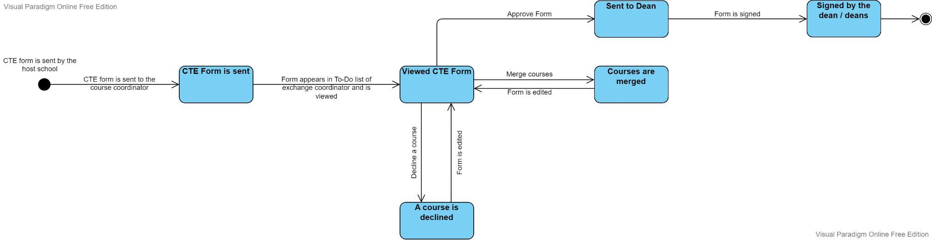

### 

### 

### 

#### 

The final state diagram shows the states for the CTE forms. After the host school sends the CTE form, it is reviewed by the exchange coordinator. The exchange coordinator can merge some courses if they have very low credits (French schools) or decline a course if it was irrelevant or too easy like a project course. After this editing, the form is sent to the dean and the dean of the department signs the form. If the student has a double major, it is also signed by the dean of the second major’s department.

#### 3.5.2.3 Sequence Diagrams

##### **3.5.2.3.1 Sequence Diagram for Pre-approval Forms**

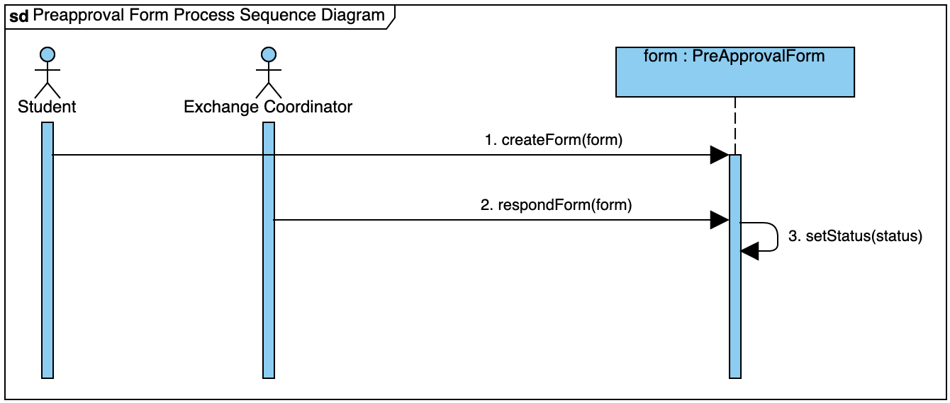

A student starts the pre-approval form process by creating the form via the “createForm” method. Then, an exchange coordinator responds to the form via the “respondForm” method. This method triggers the “setStatus” method of the pre-approval form.

##### **3.5.2.3.2 Sequence Diagram for CTE Forms**

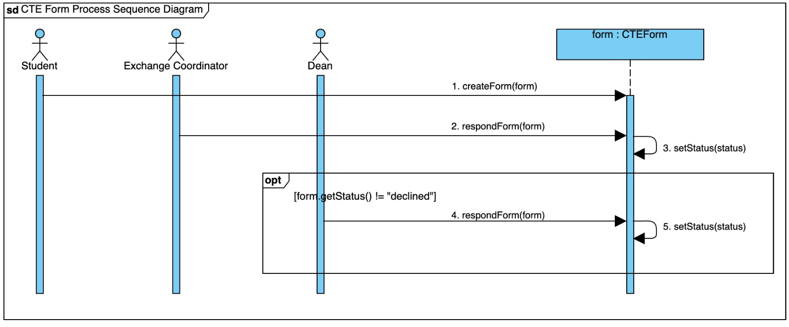

A student starts the CTE form process by creating the form via the “createForm” method. Then, an exchange coordinator responds to the form via the “respondForm” method. This method triggers the “setStatus” method of the pre-approval form. If the form is not declined by an exchange coordinator, the dean will then respond to the form via the “respondForm” method, which triggers the “setStatus” method of the form.

##### **3.5.2.3.3 Sequence Diagram for Equivalence Requests**

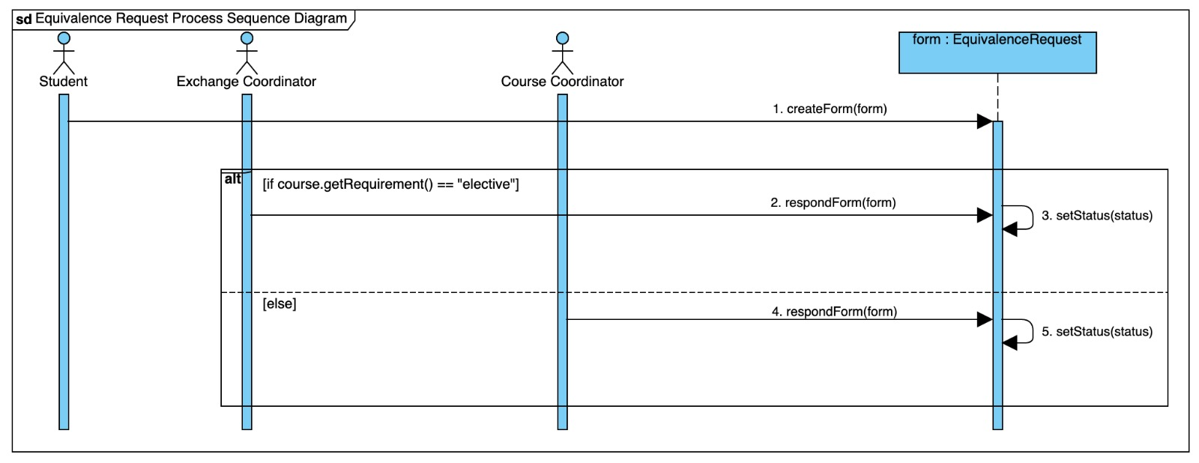

A student starts the CTE form process by creating the form via the “createForm” method. The next actor depends on the type of the course. If the course is an elective course, then the form is responded to by an exchange coordinator via the “respondForm” method. Otherwise, the coordinator of the corresponding mandatory course responds to the form via the “respondForm” method. After the response, the “setStatus” method of the form is triggered.

### 

### 

### **3.5.3 Object and Class Model**

### **3.5.4 User Interface**

#### 3.5.4.1 Login and Sign Up Screens

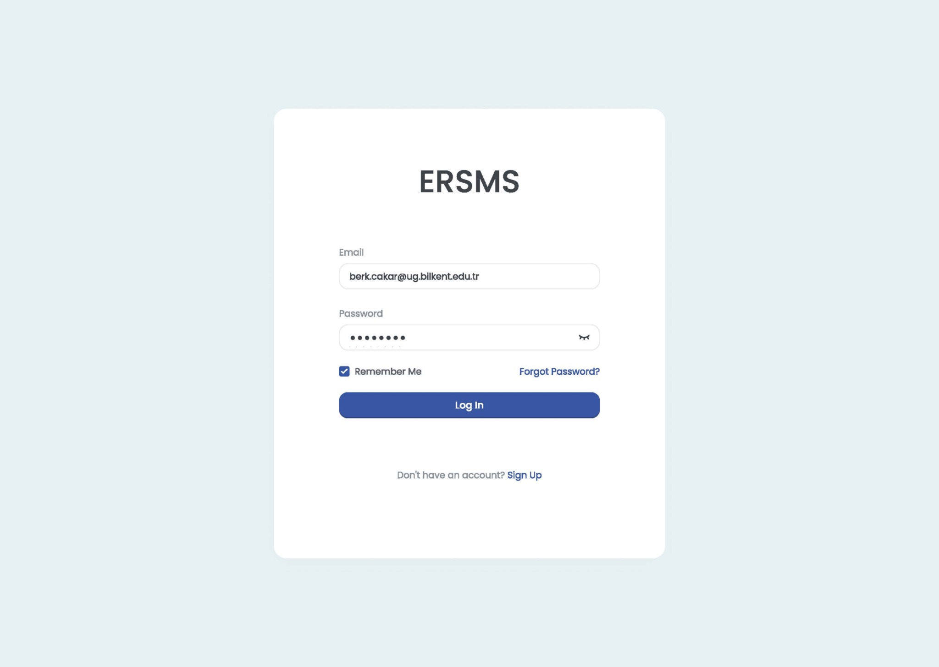

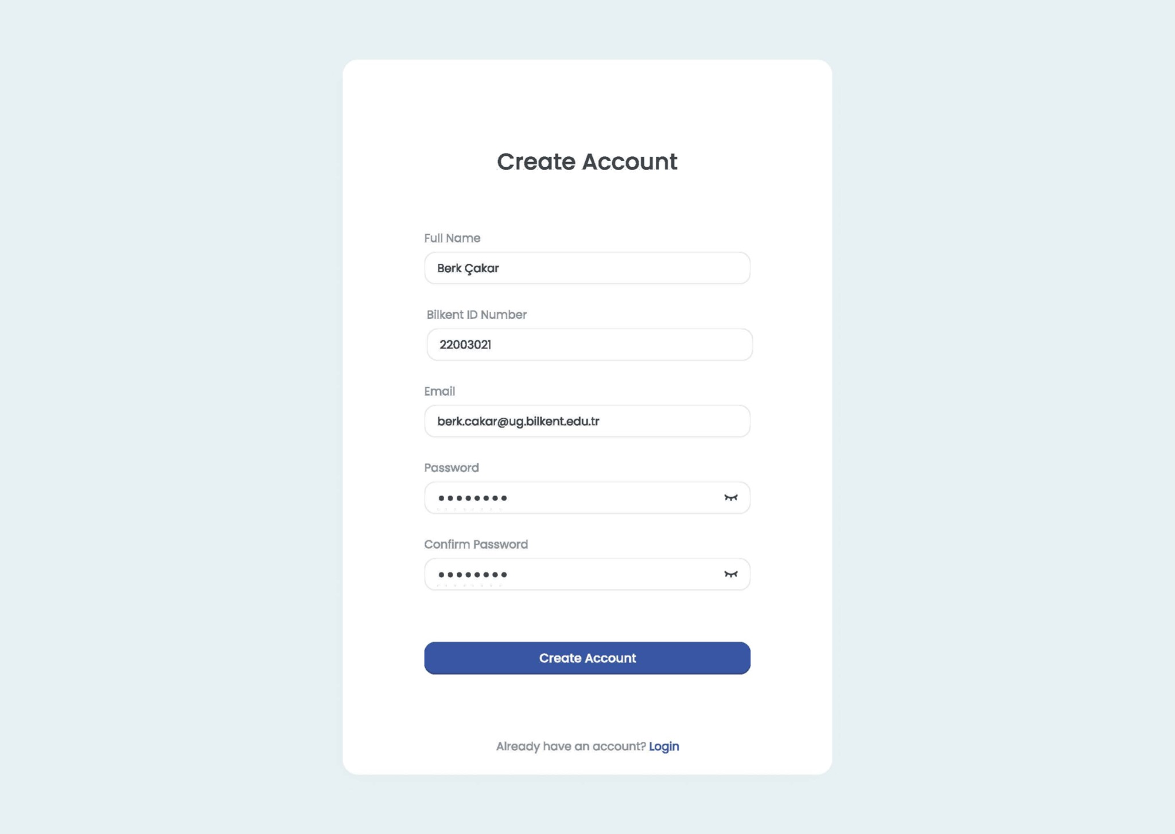

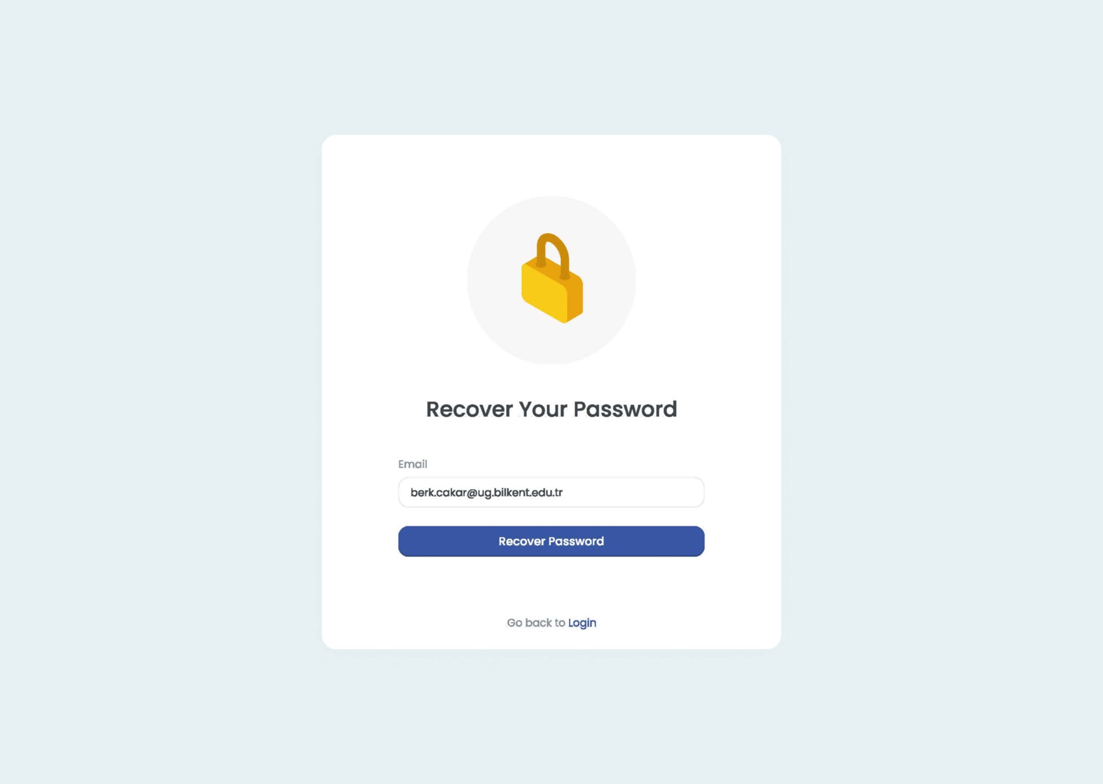

#### 3.5.4.2 Exchange Coordinator Dashboard Screen

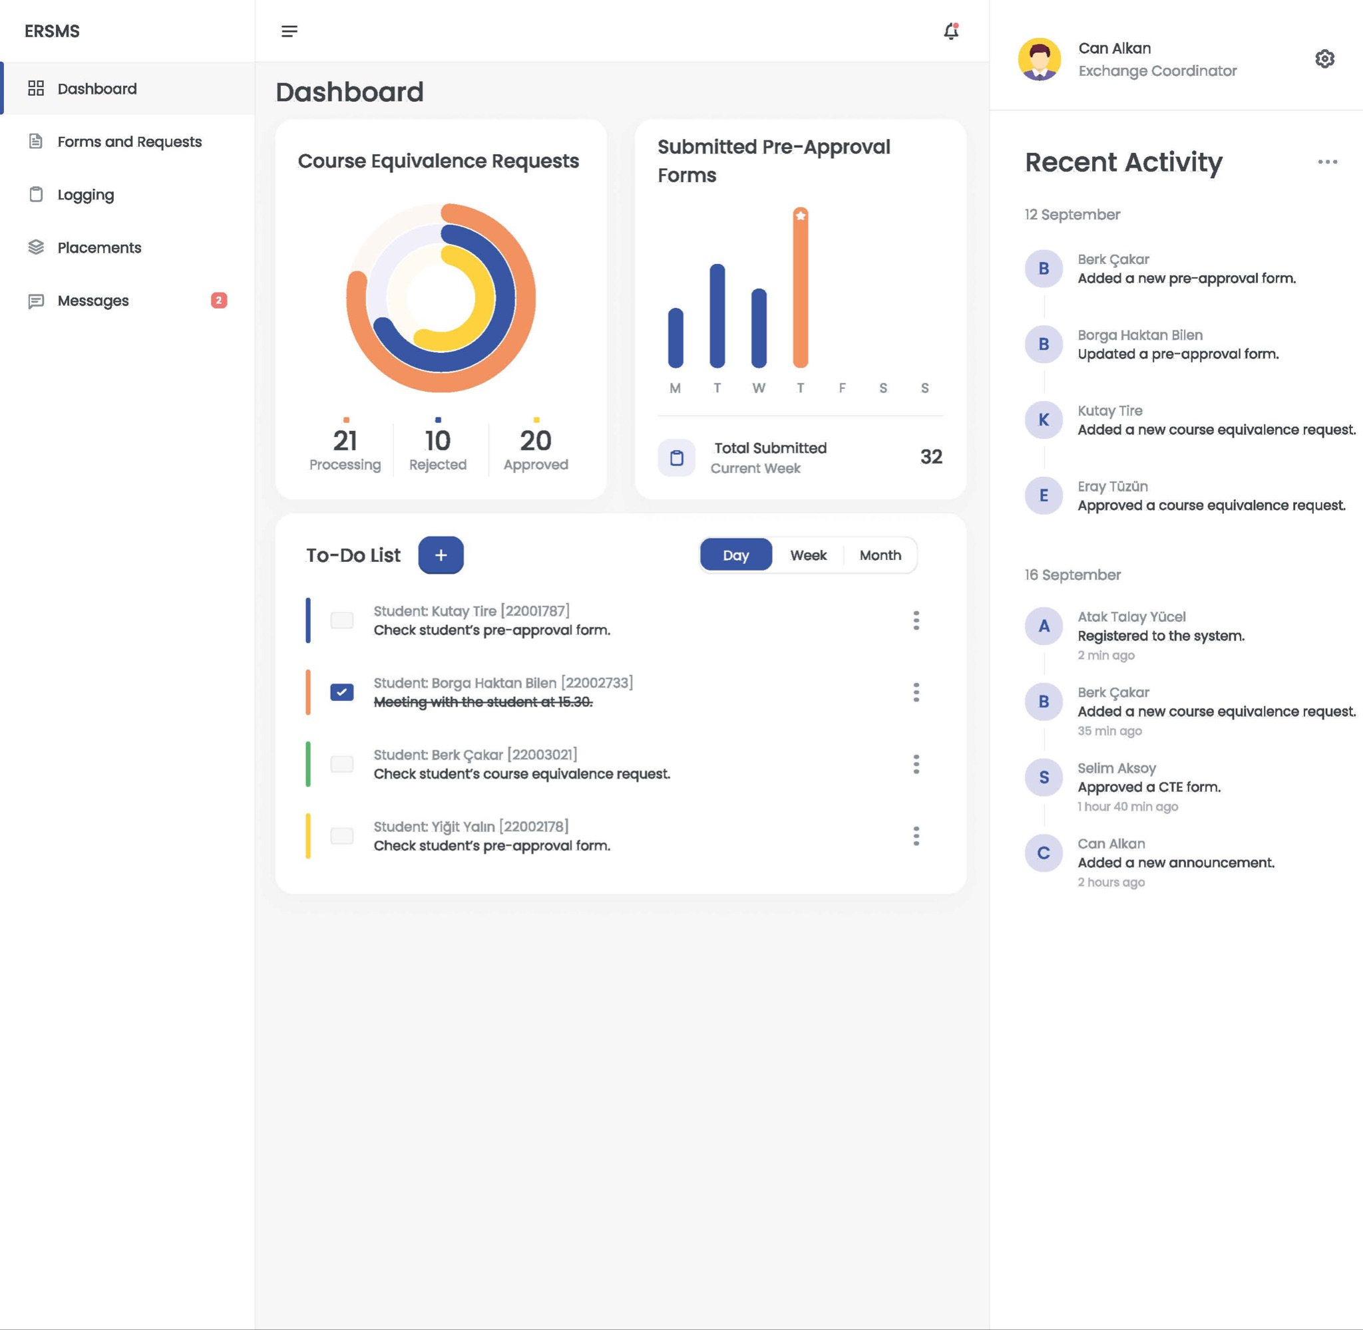

#### 3.5.4.3 Exchange Coordinator Forms Screen

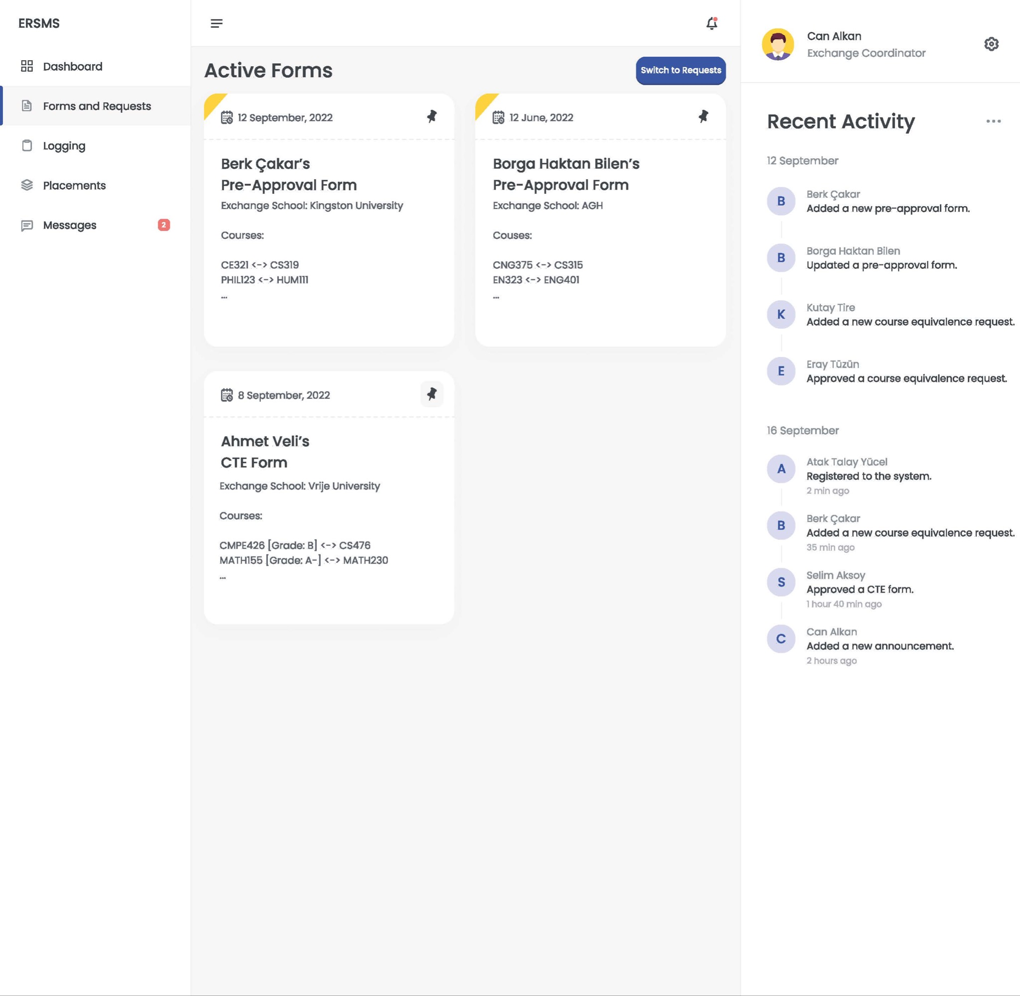

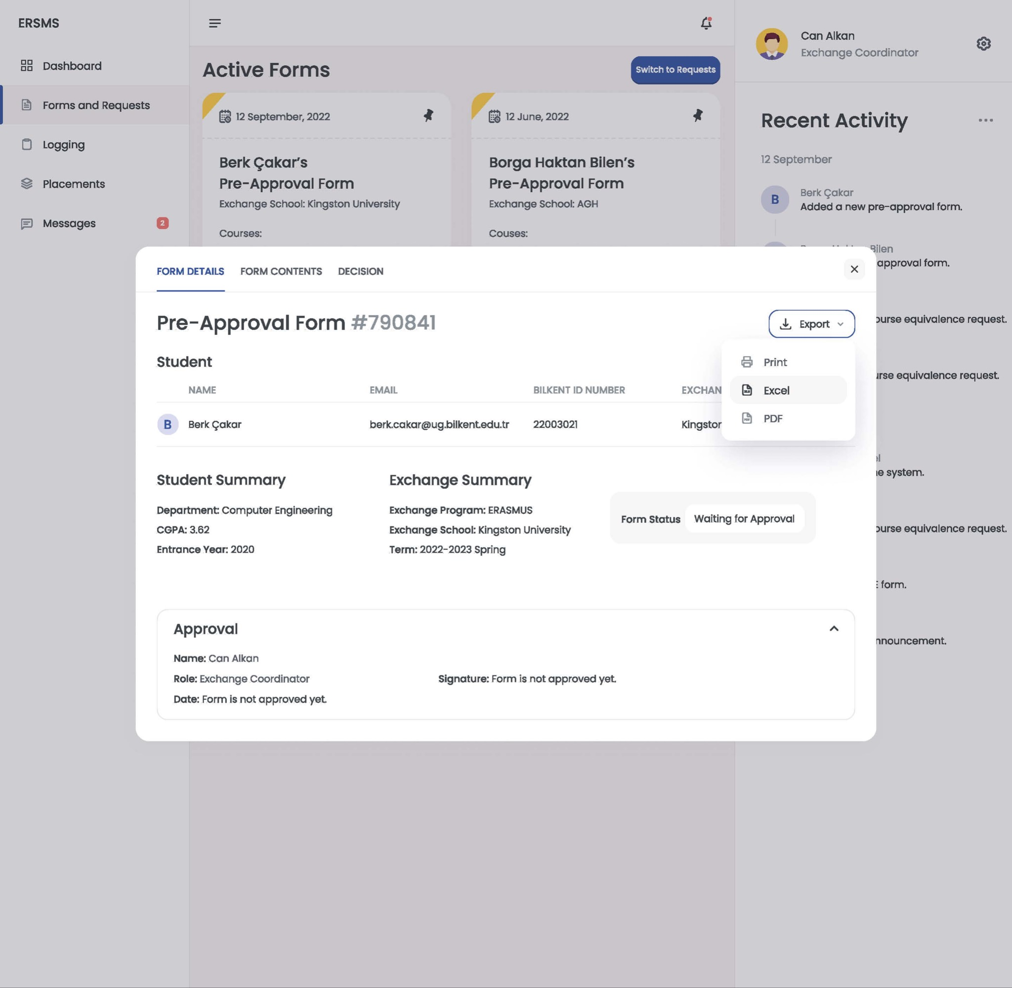

#### 3.5.4.4 Logging Screen

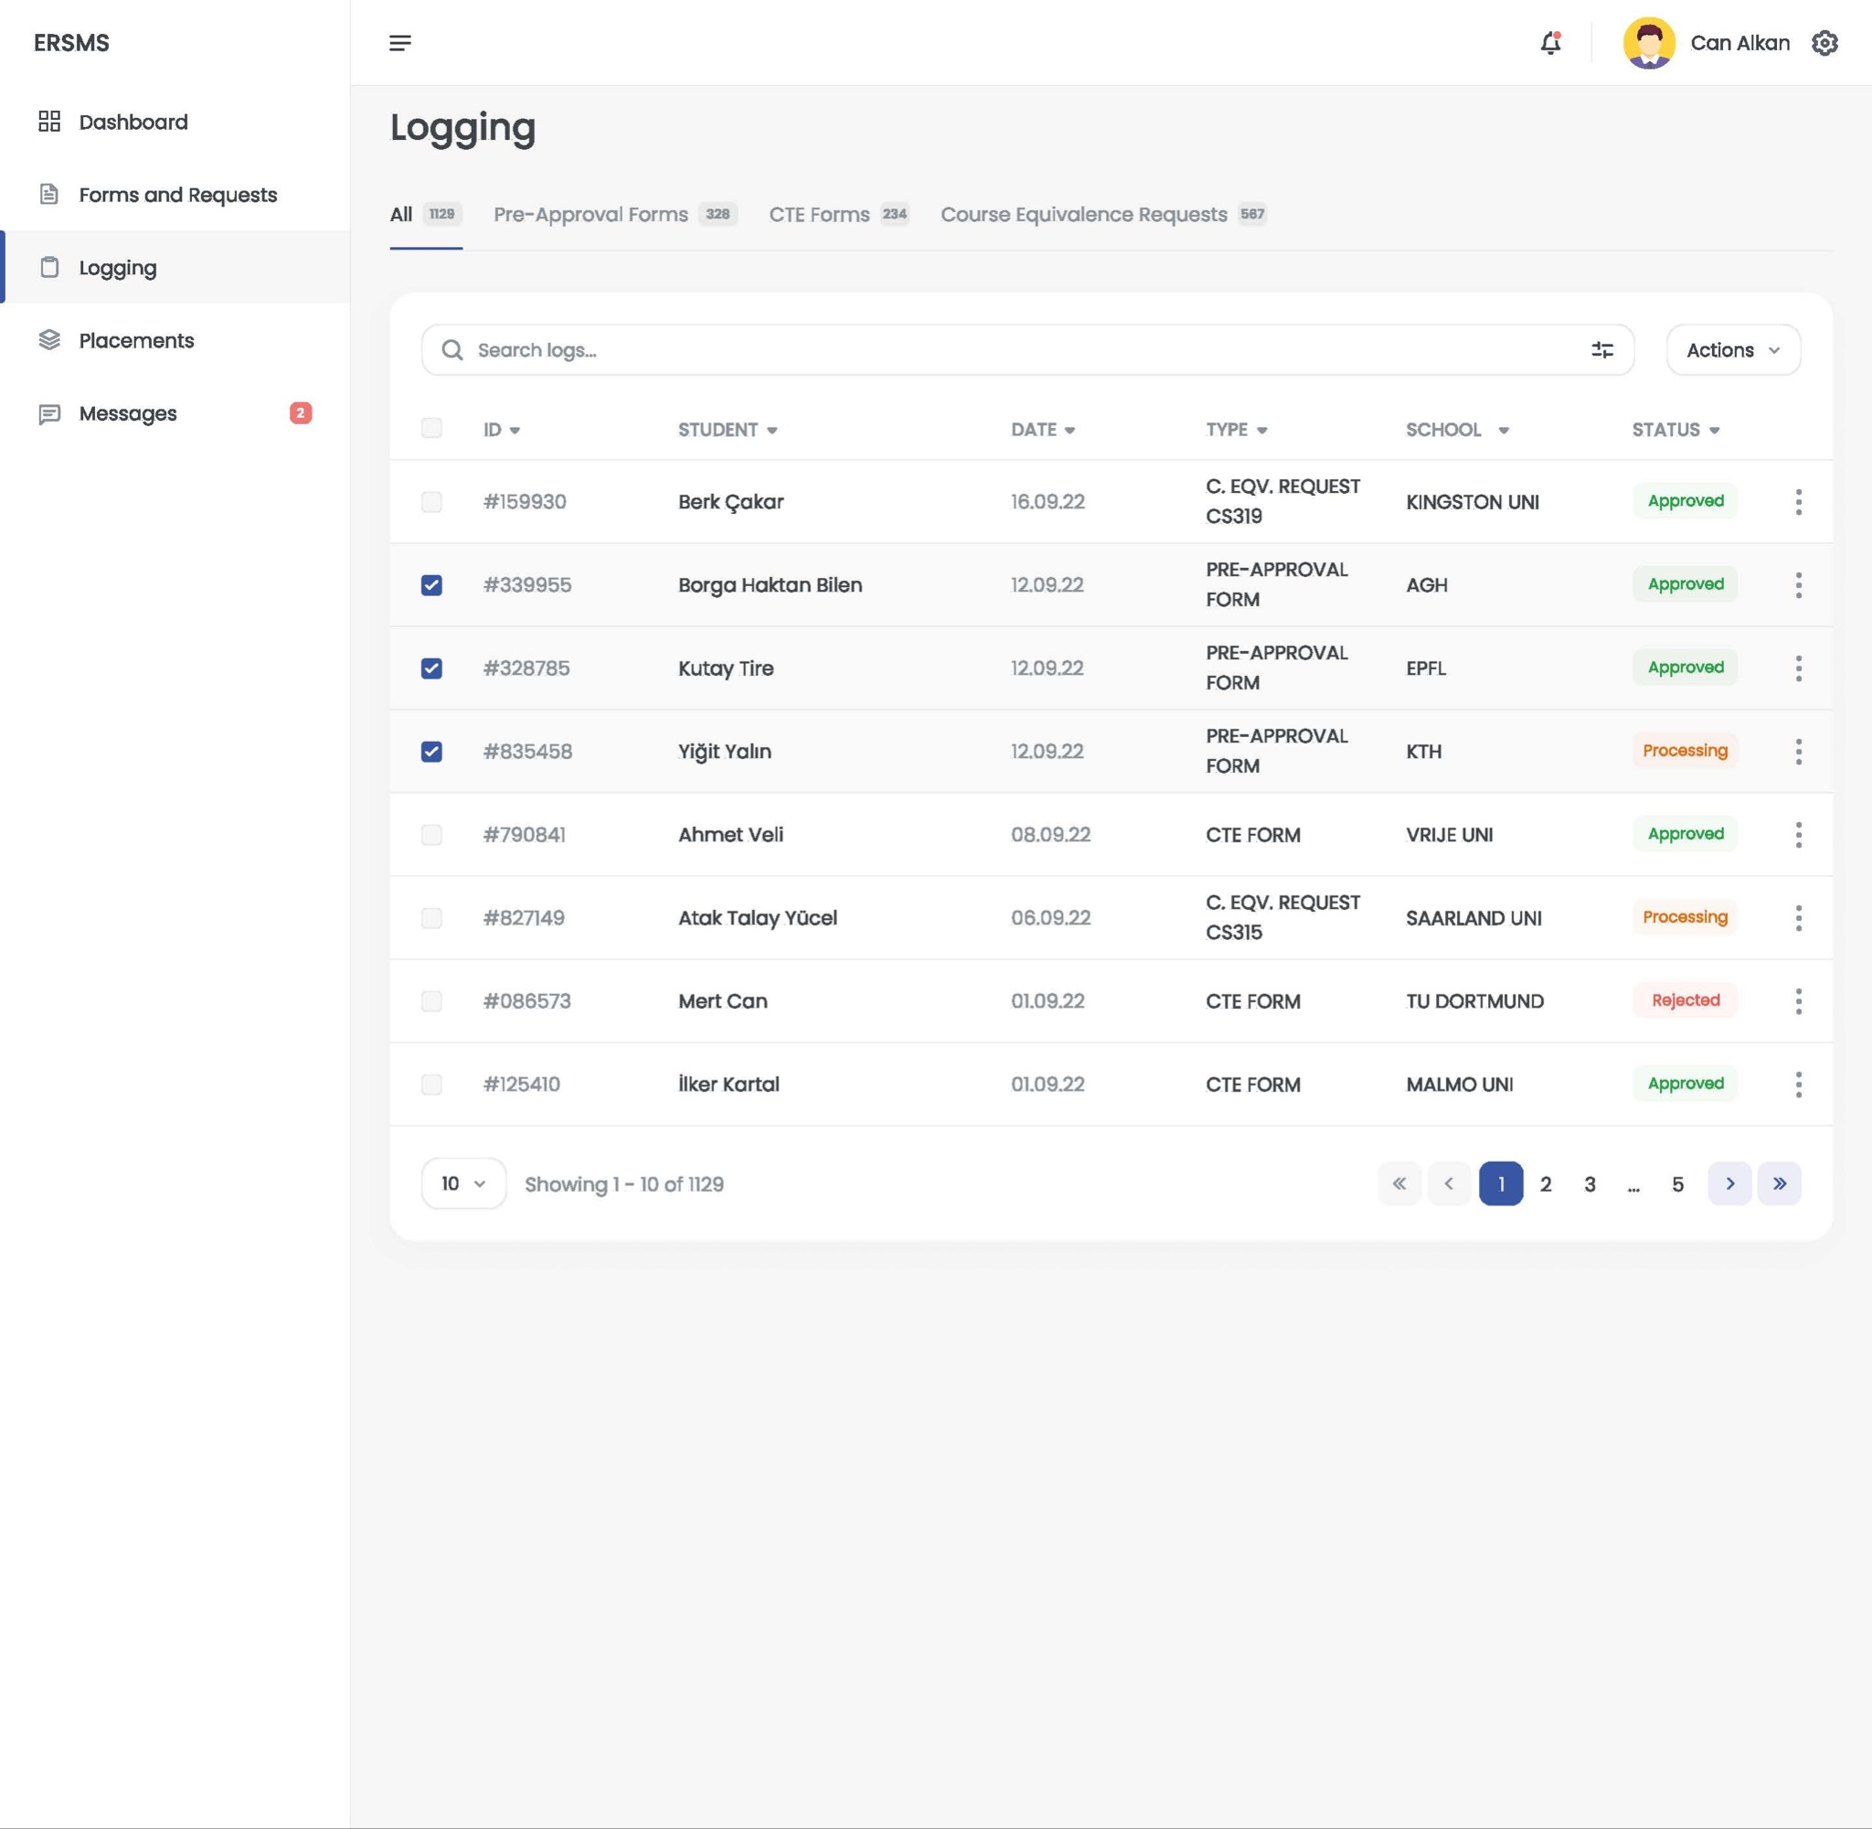

Note that this screen is from an exchange coordinator’s perspective, but still for the other actors it will be a variant of this screen. For example, for the students only the “Course Equivalence Requests” tab will be visible with students’ names hidden.

#### 3.5.4.5 Placements Screen

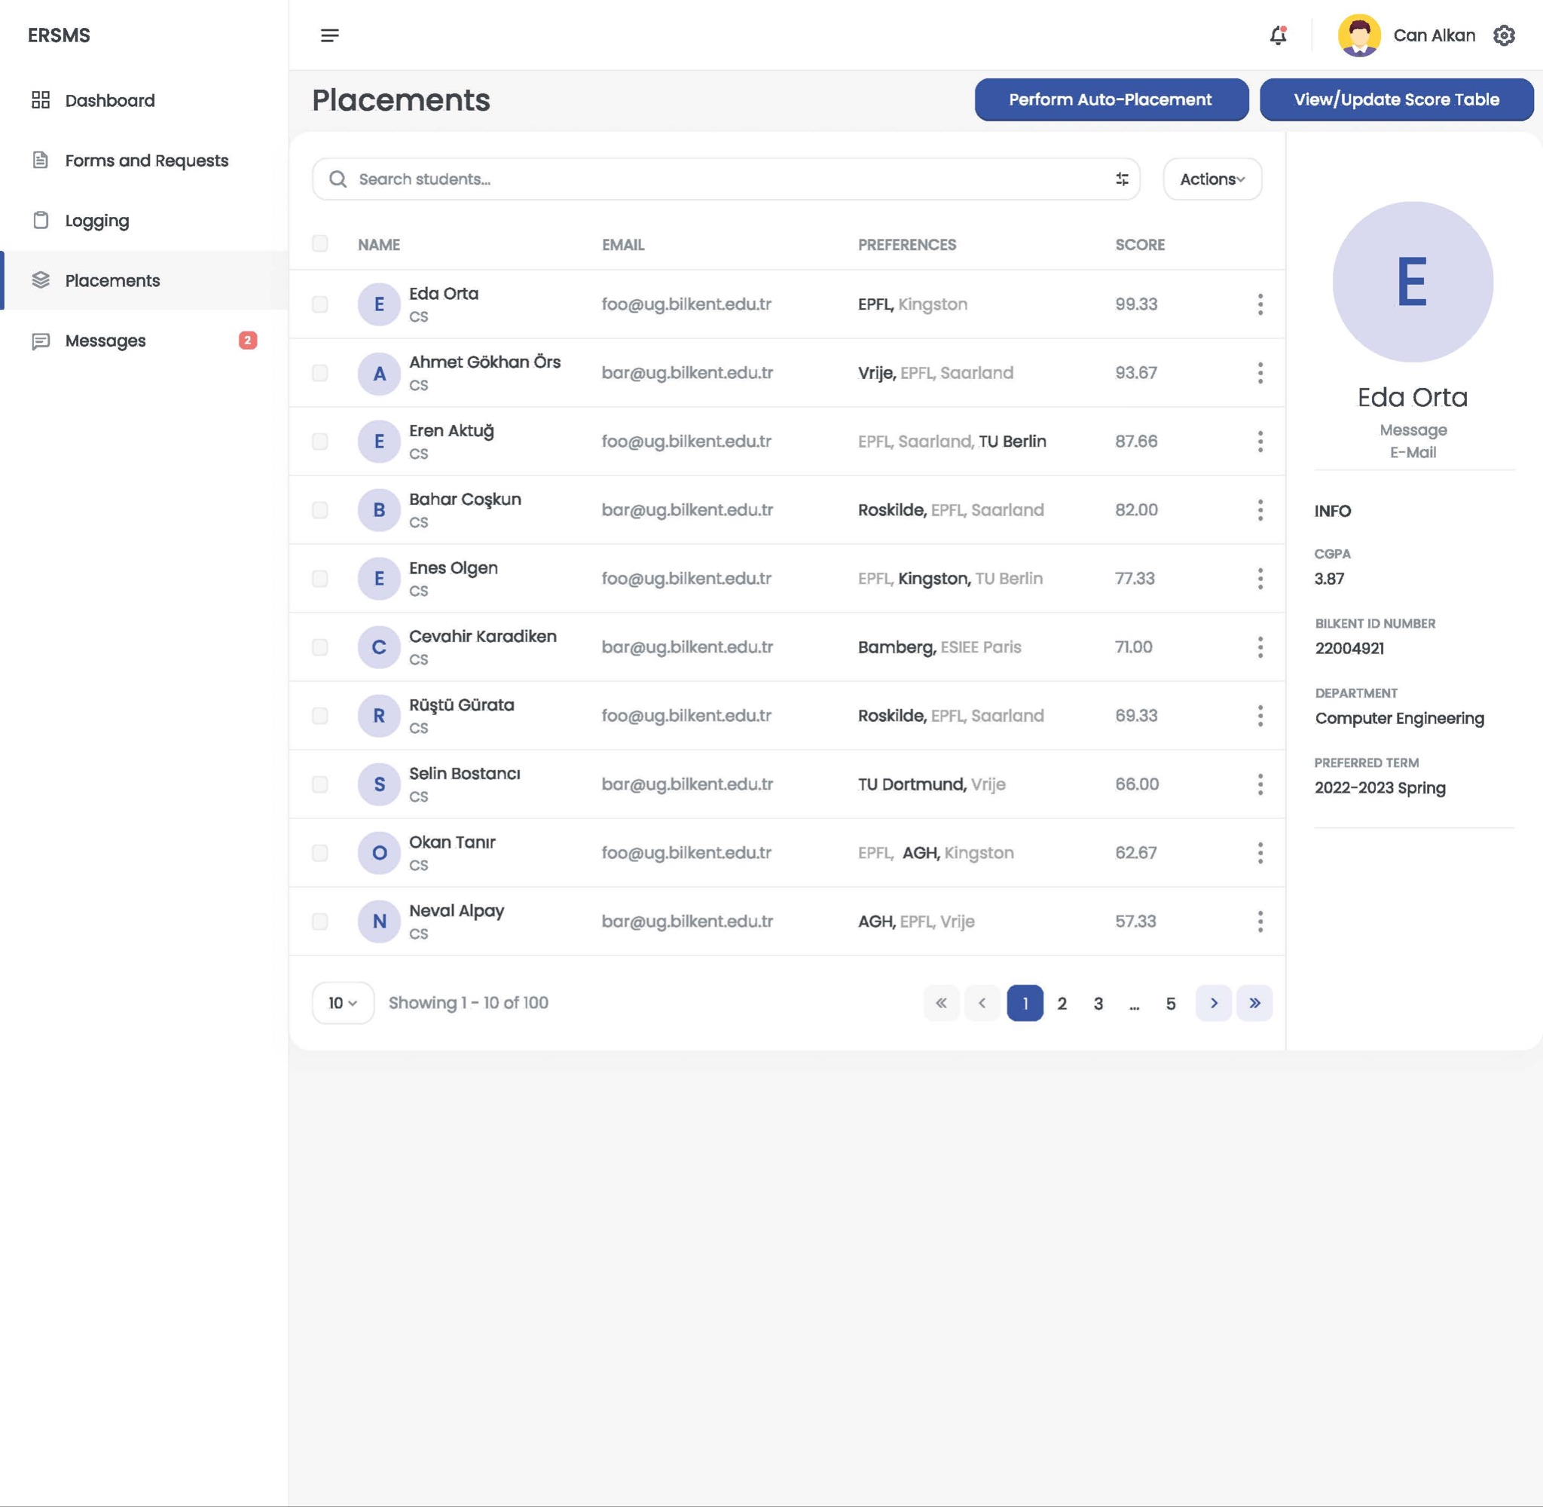

#### 

#### 3.5.4.6 Messages Screen

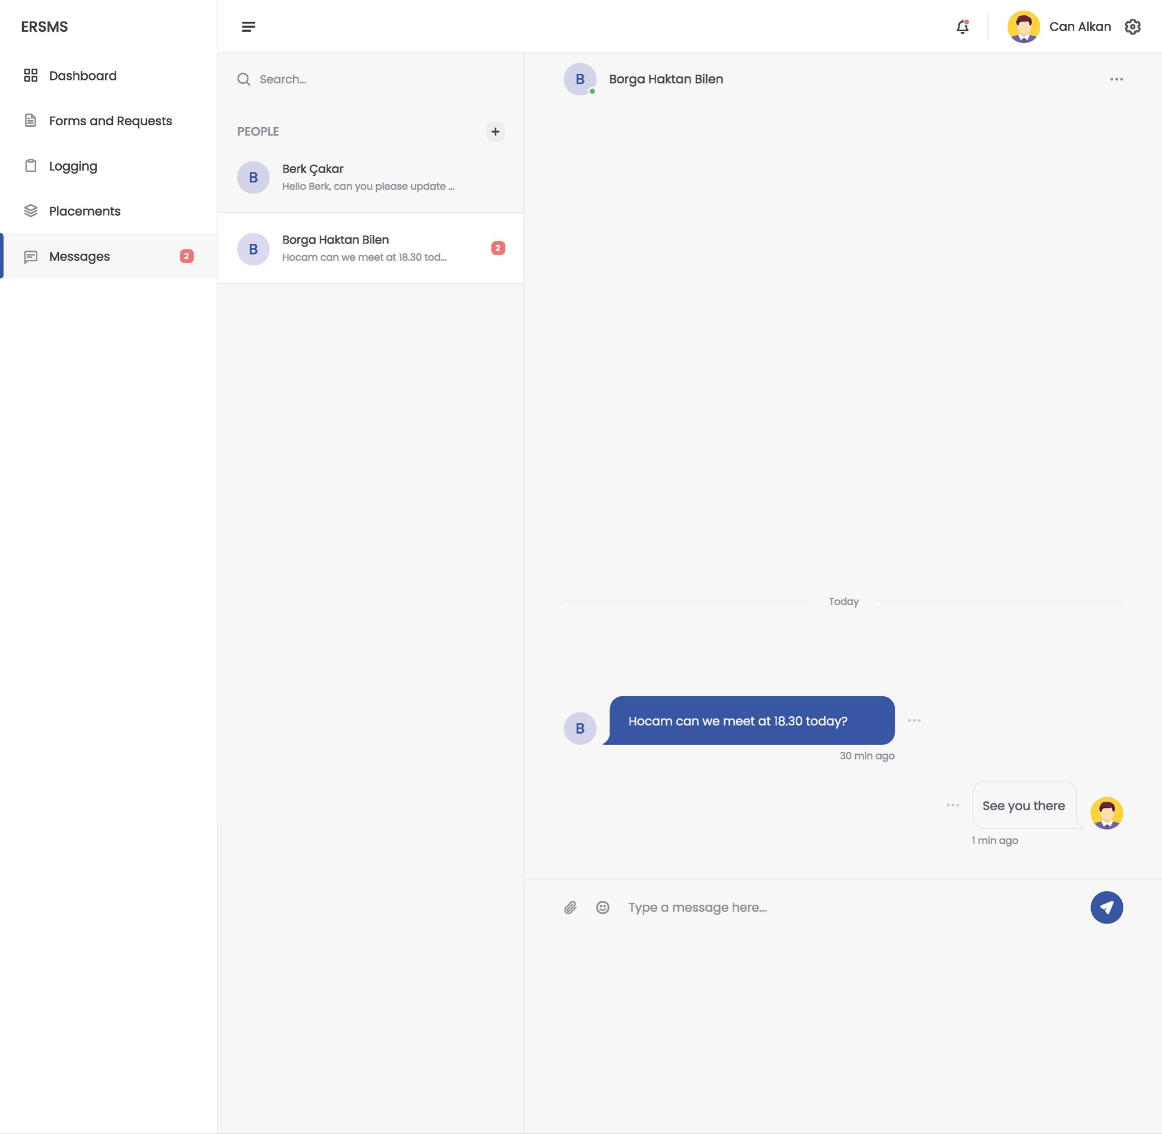

#### 3.5.4.7 Instructor/Course Coordinator Course Equivalence Requests Screen

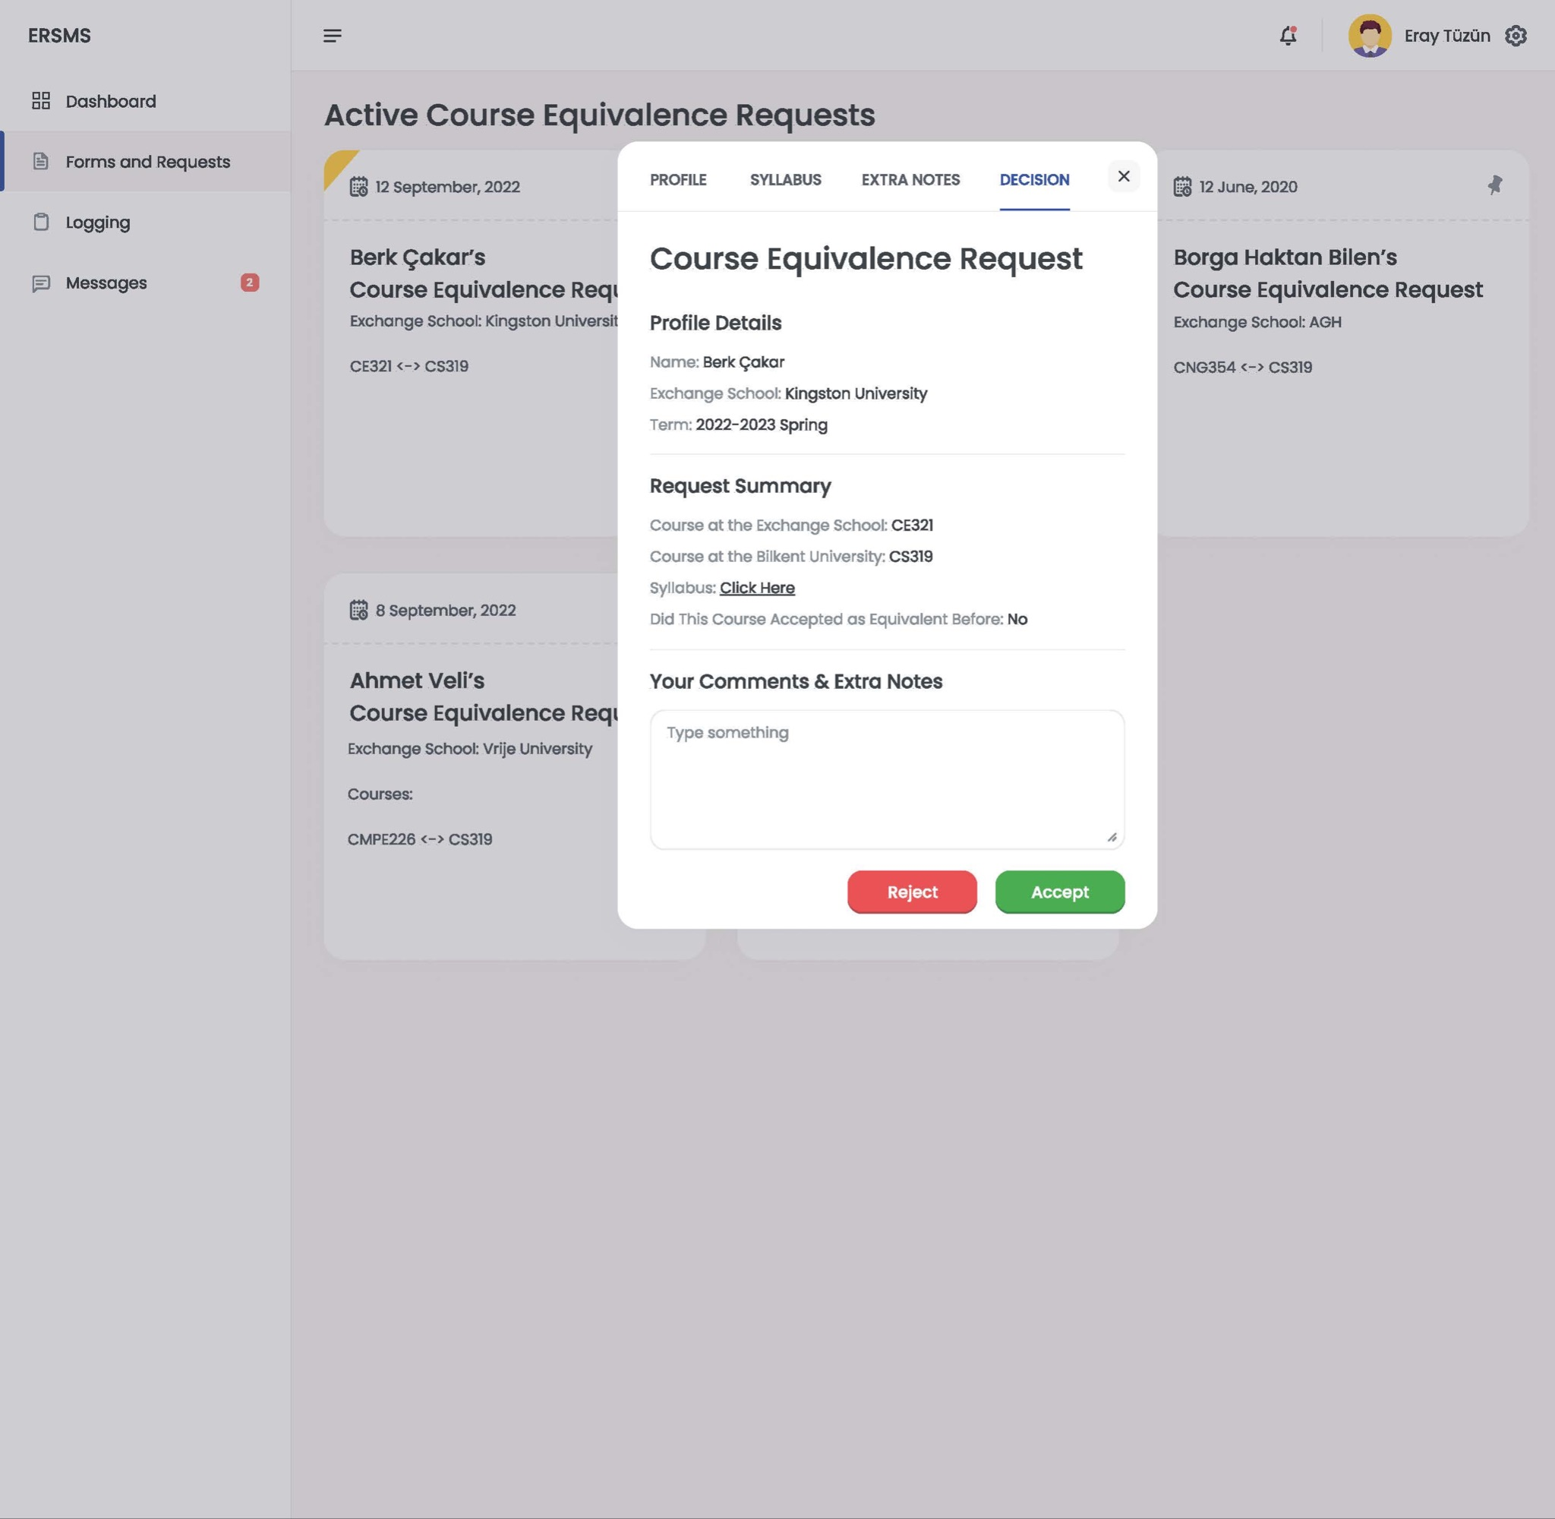

#### 3.5.4.8 Profile Screen

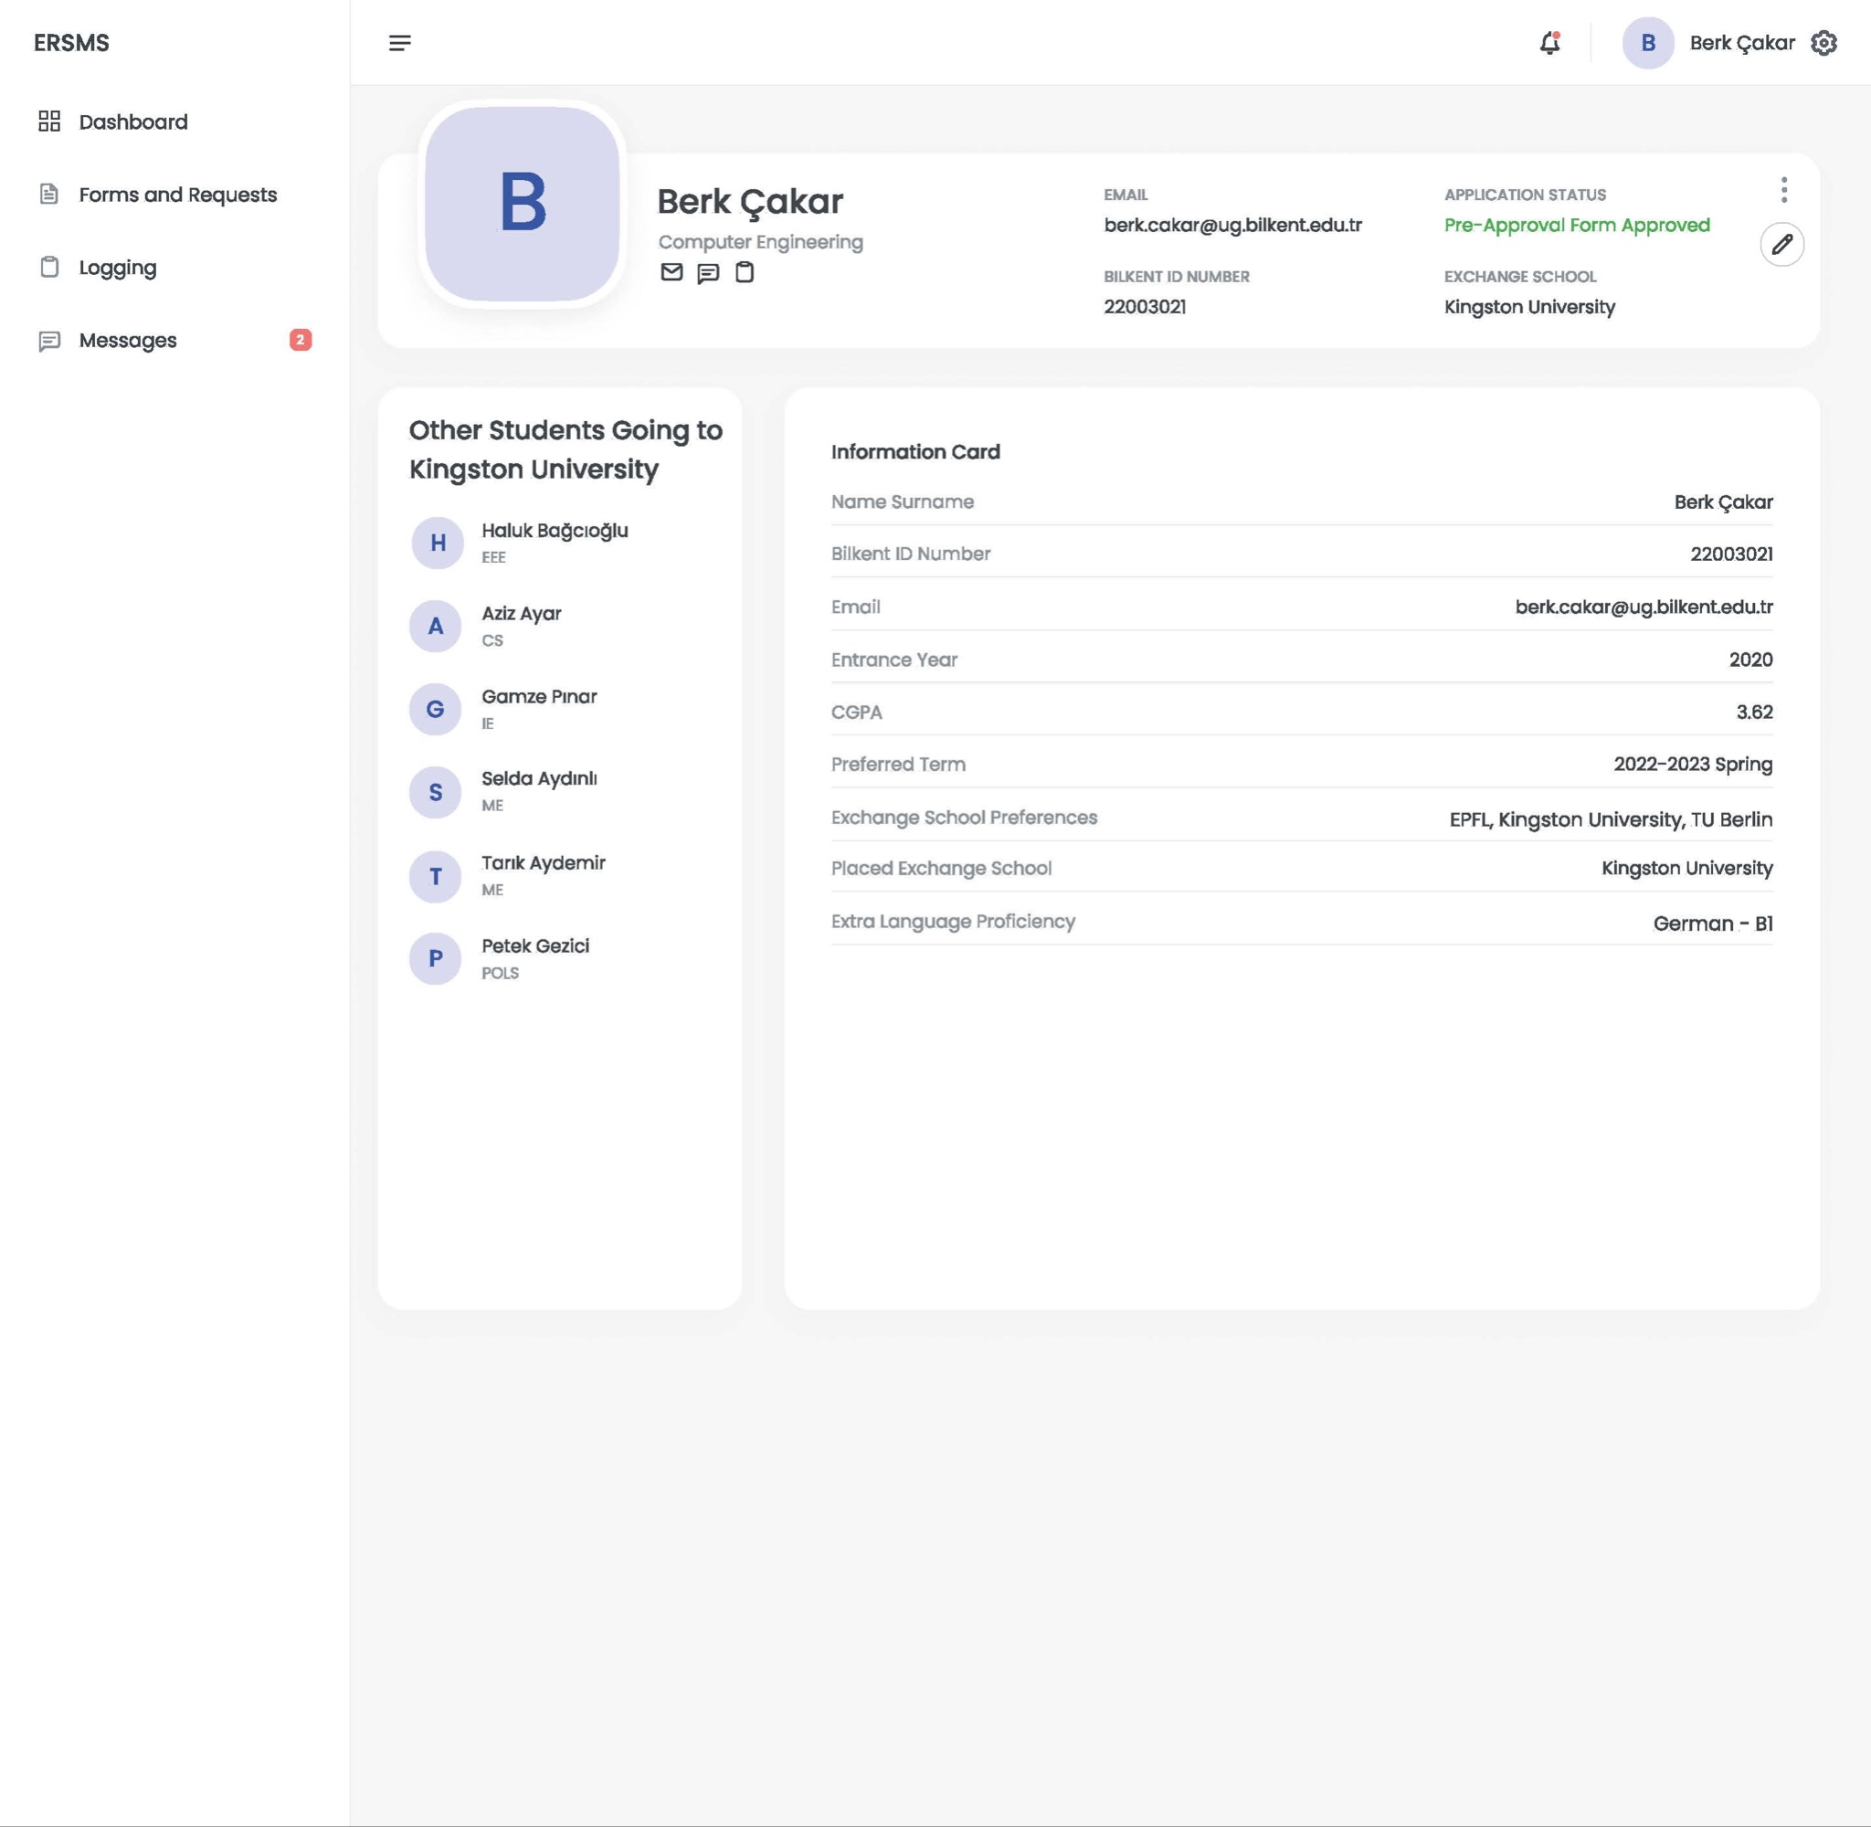

#### 3.5.4.9 Student Dashboard Screen

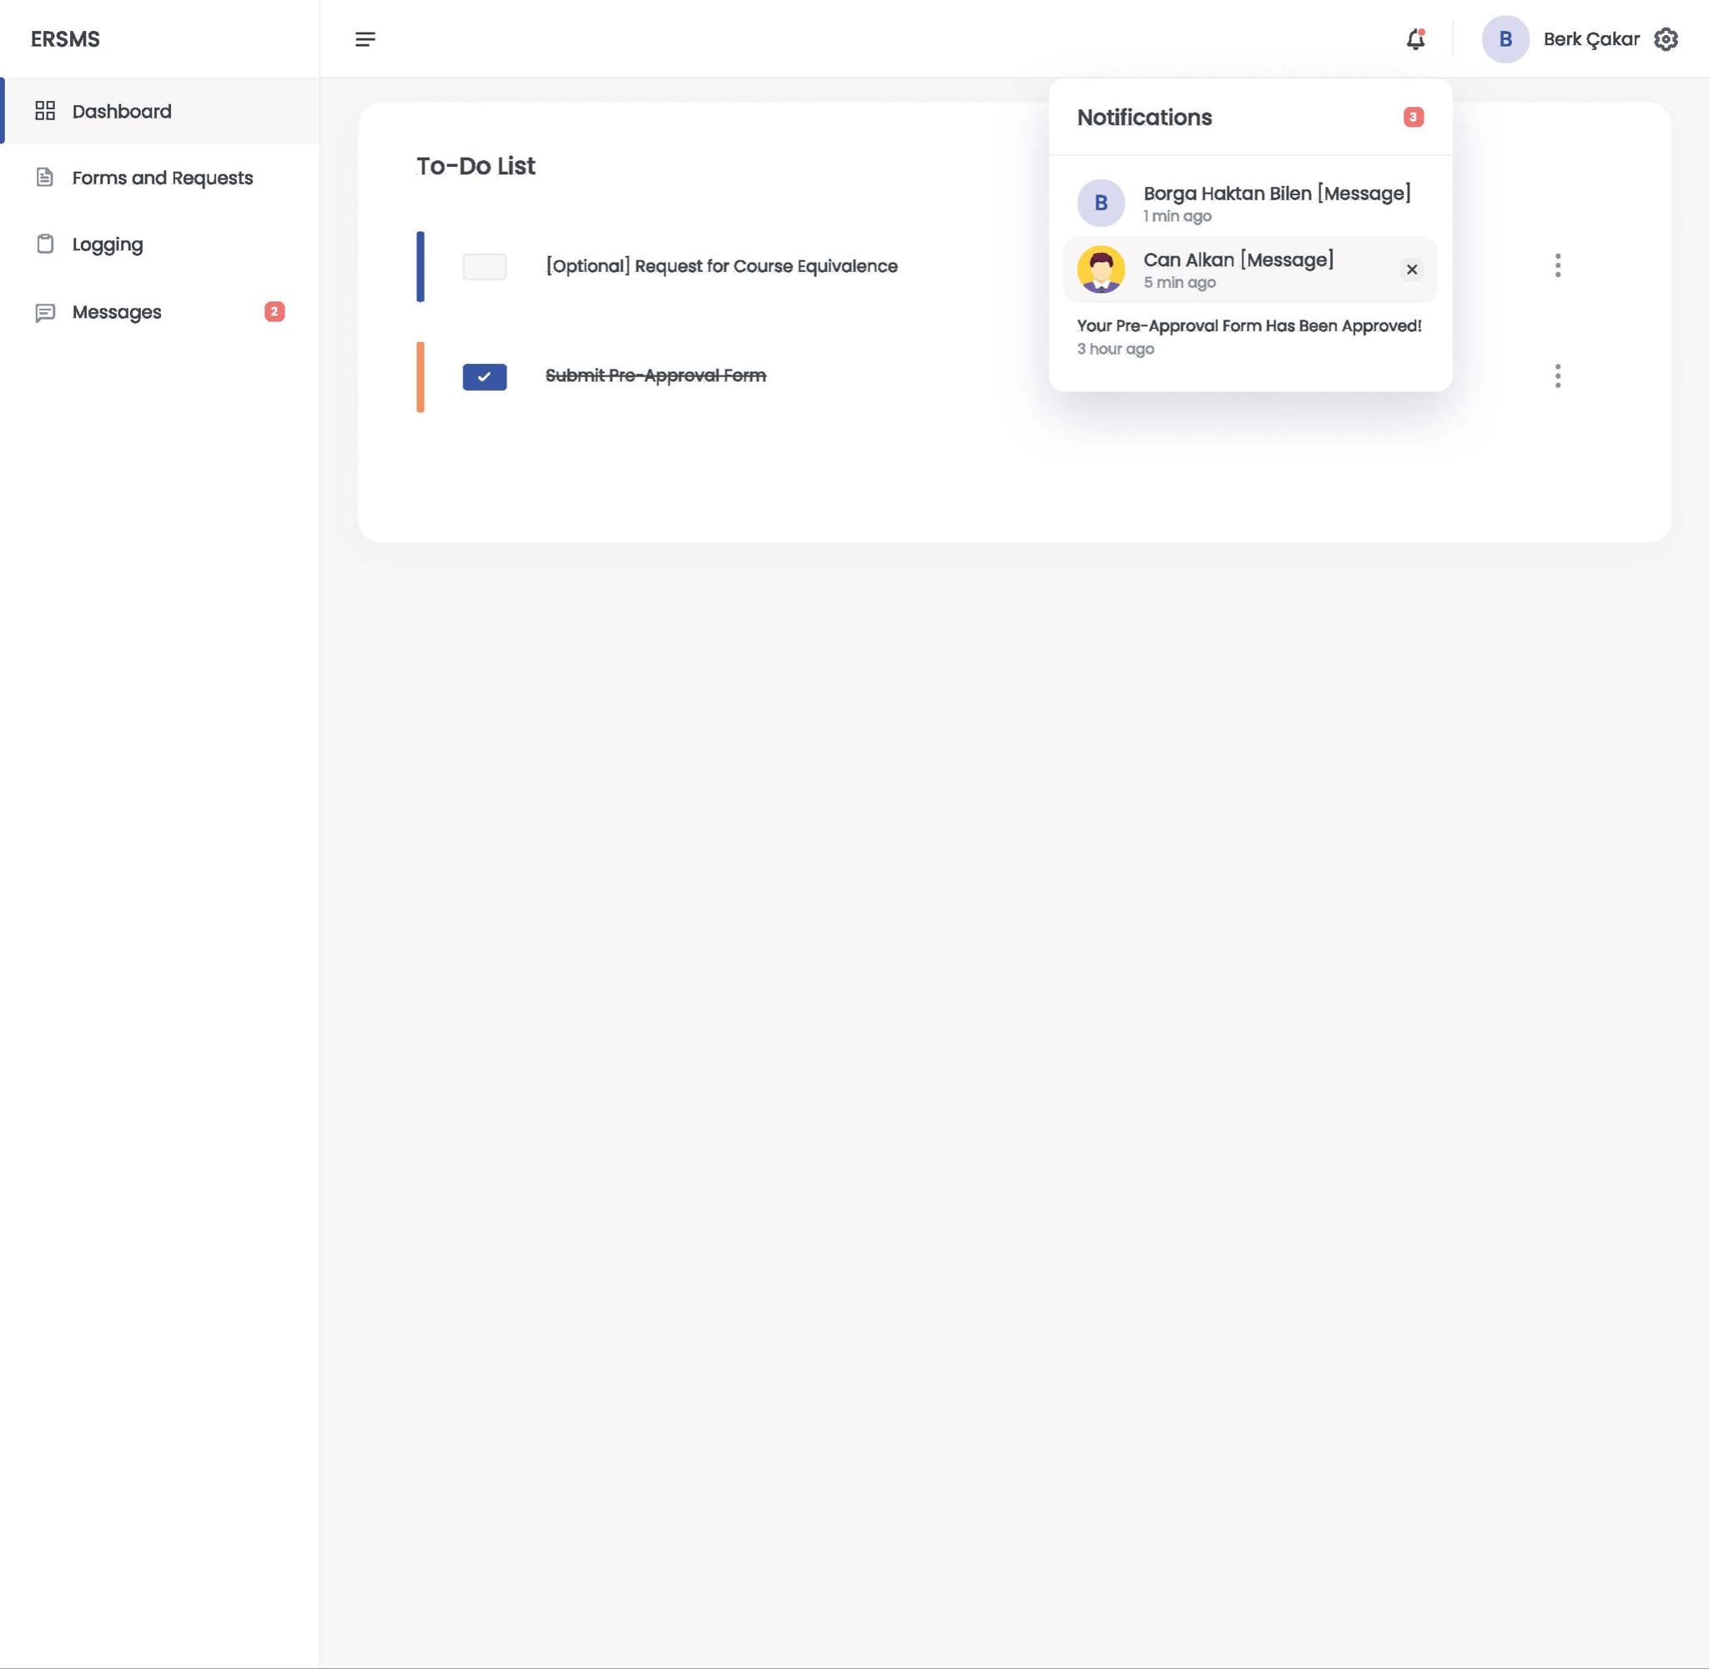

#### 3.5.4.10 Student Form Submission Screen

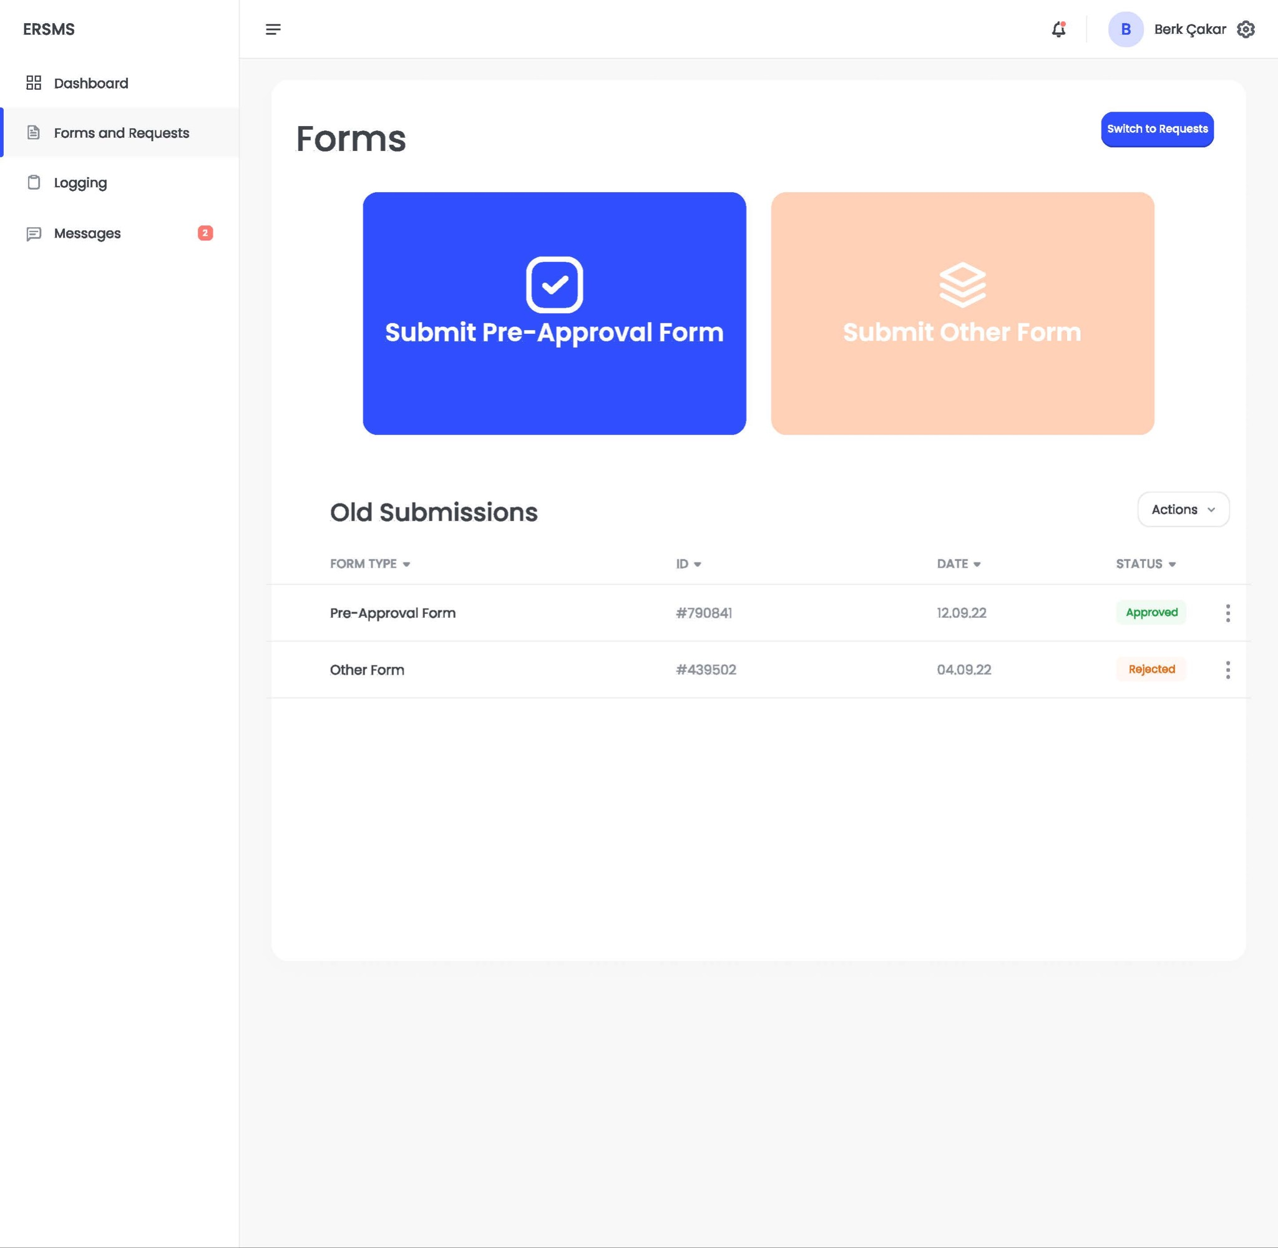

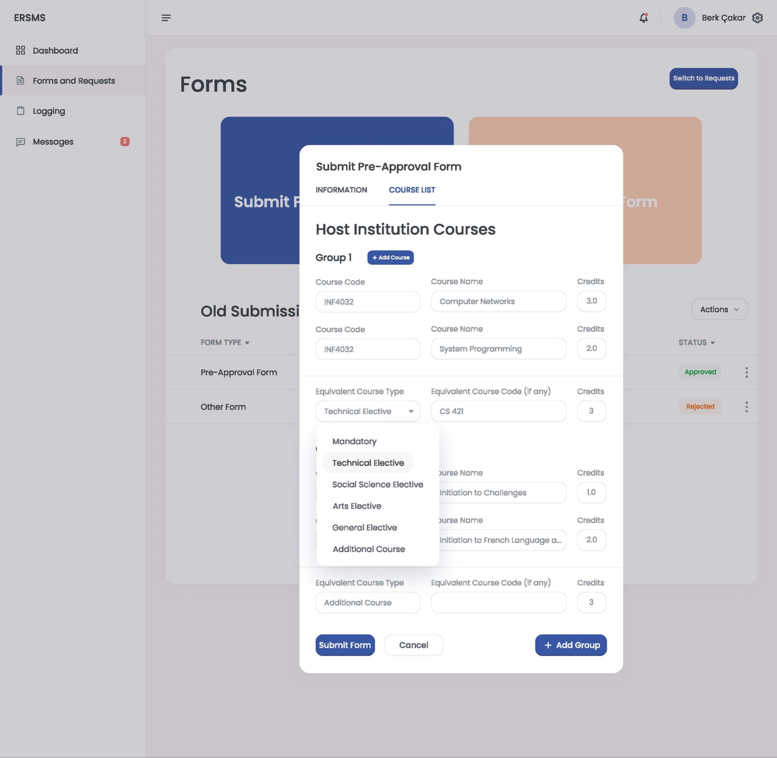

#### 

#### 3.5.4.11 OISEP Score Table Upload Screen

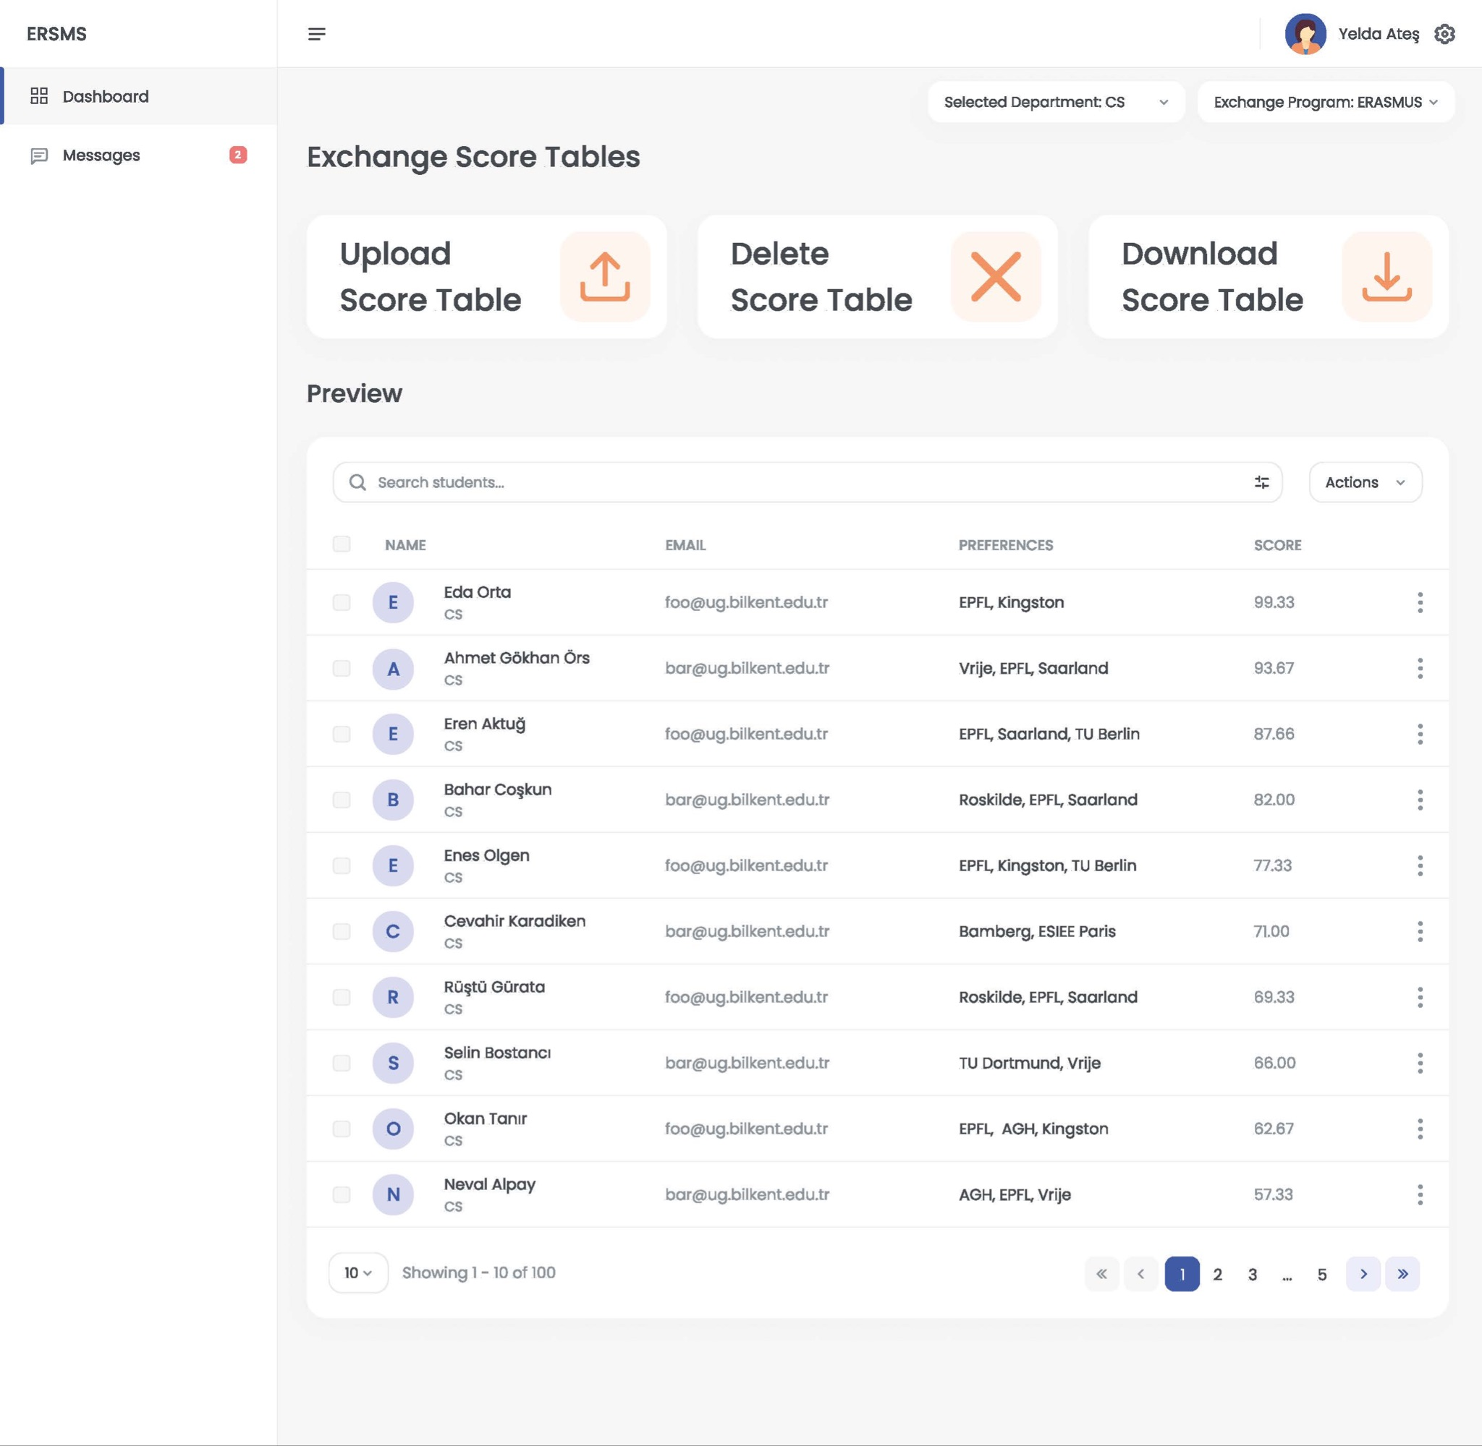

# 

# 4 References

1. Object-Oriented Software Engineering, Using UML, Patterns, and Java, 2nd Edition, by Bernd Bruegge and Allen H. Dutoit, Prentice-Hall, 2004, ISBN: 0-13-047110-0.